# **Create EC2 Instance in AWS: -**

1. Step 1: Login to the aws console
2. Step 2: Choose Launch Instance
3. Step 3: Choose AMI
4. Step 4: Choose EC2 Instance Types
5. Step 5: Configure Instance Details
6. Step 6: Add Storage of Ec2 Instance
7. Step 7: Tag Instance of Ec2 Instance
8. Step 8: Configure Security Groups
9. Step 9: Review Instances
10. Step 10: Create Key-Pair for Instance Access

### **Step 1: Login to the aws console: -**

I use this link <https://console.aws.amazon.com/ec2/> to login to aws console account.

### **Step 2: Choose Launch Instance**

First of all, click on ‘Launch Instance’ button shows in the below picture for launch/create new ec2 instance in aws:

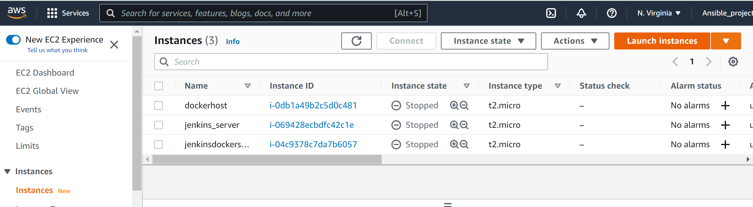

### **Step 3: Choose AMI**

In this step, choose AMI (I chose **Amazon Linux 2 AMI (HVM) - Kernel 5.10, SSD Volume Type** - **ami-0022f774911c1d690 (64-bit x86) / ami-0e449176cecc3e577 (64-bit Arm)**

### **Shown in the below fig**

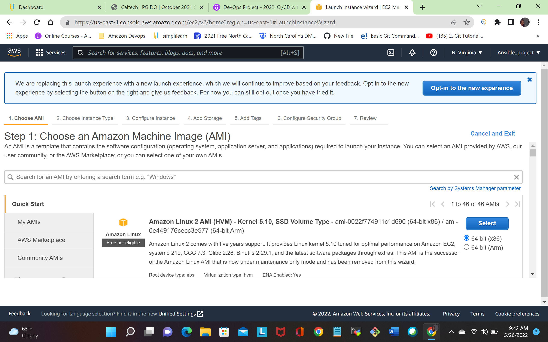

### **Step 4: Choose EC2 Instance Types**

In this step, choose ec2 instance type shown in below picture:

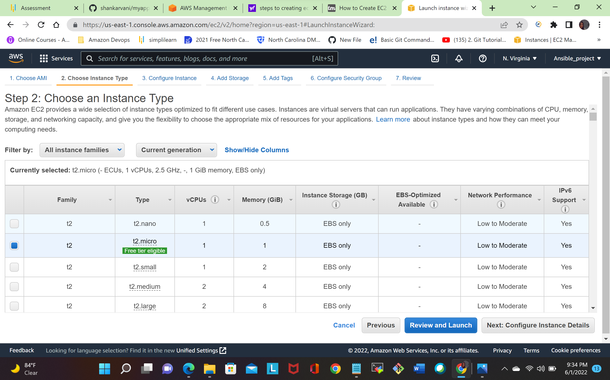

### **Step 5: Configure Instance Detail:**

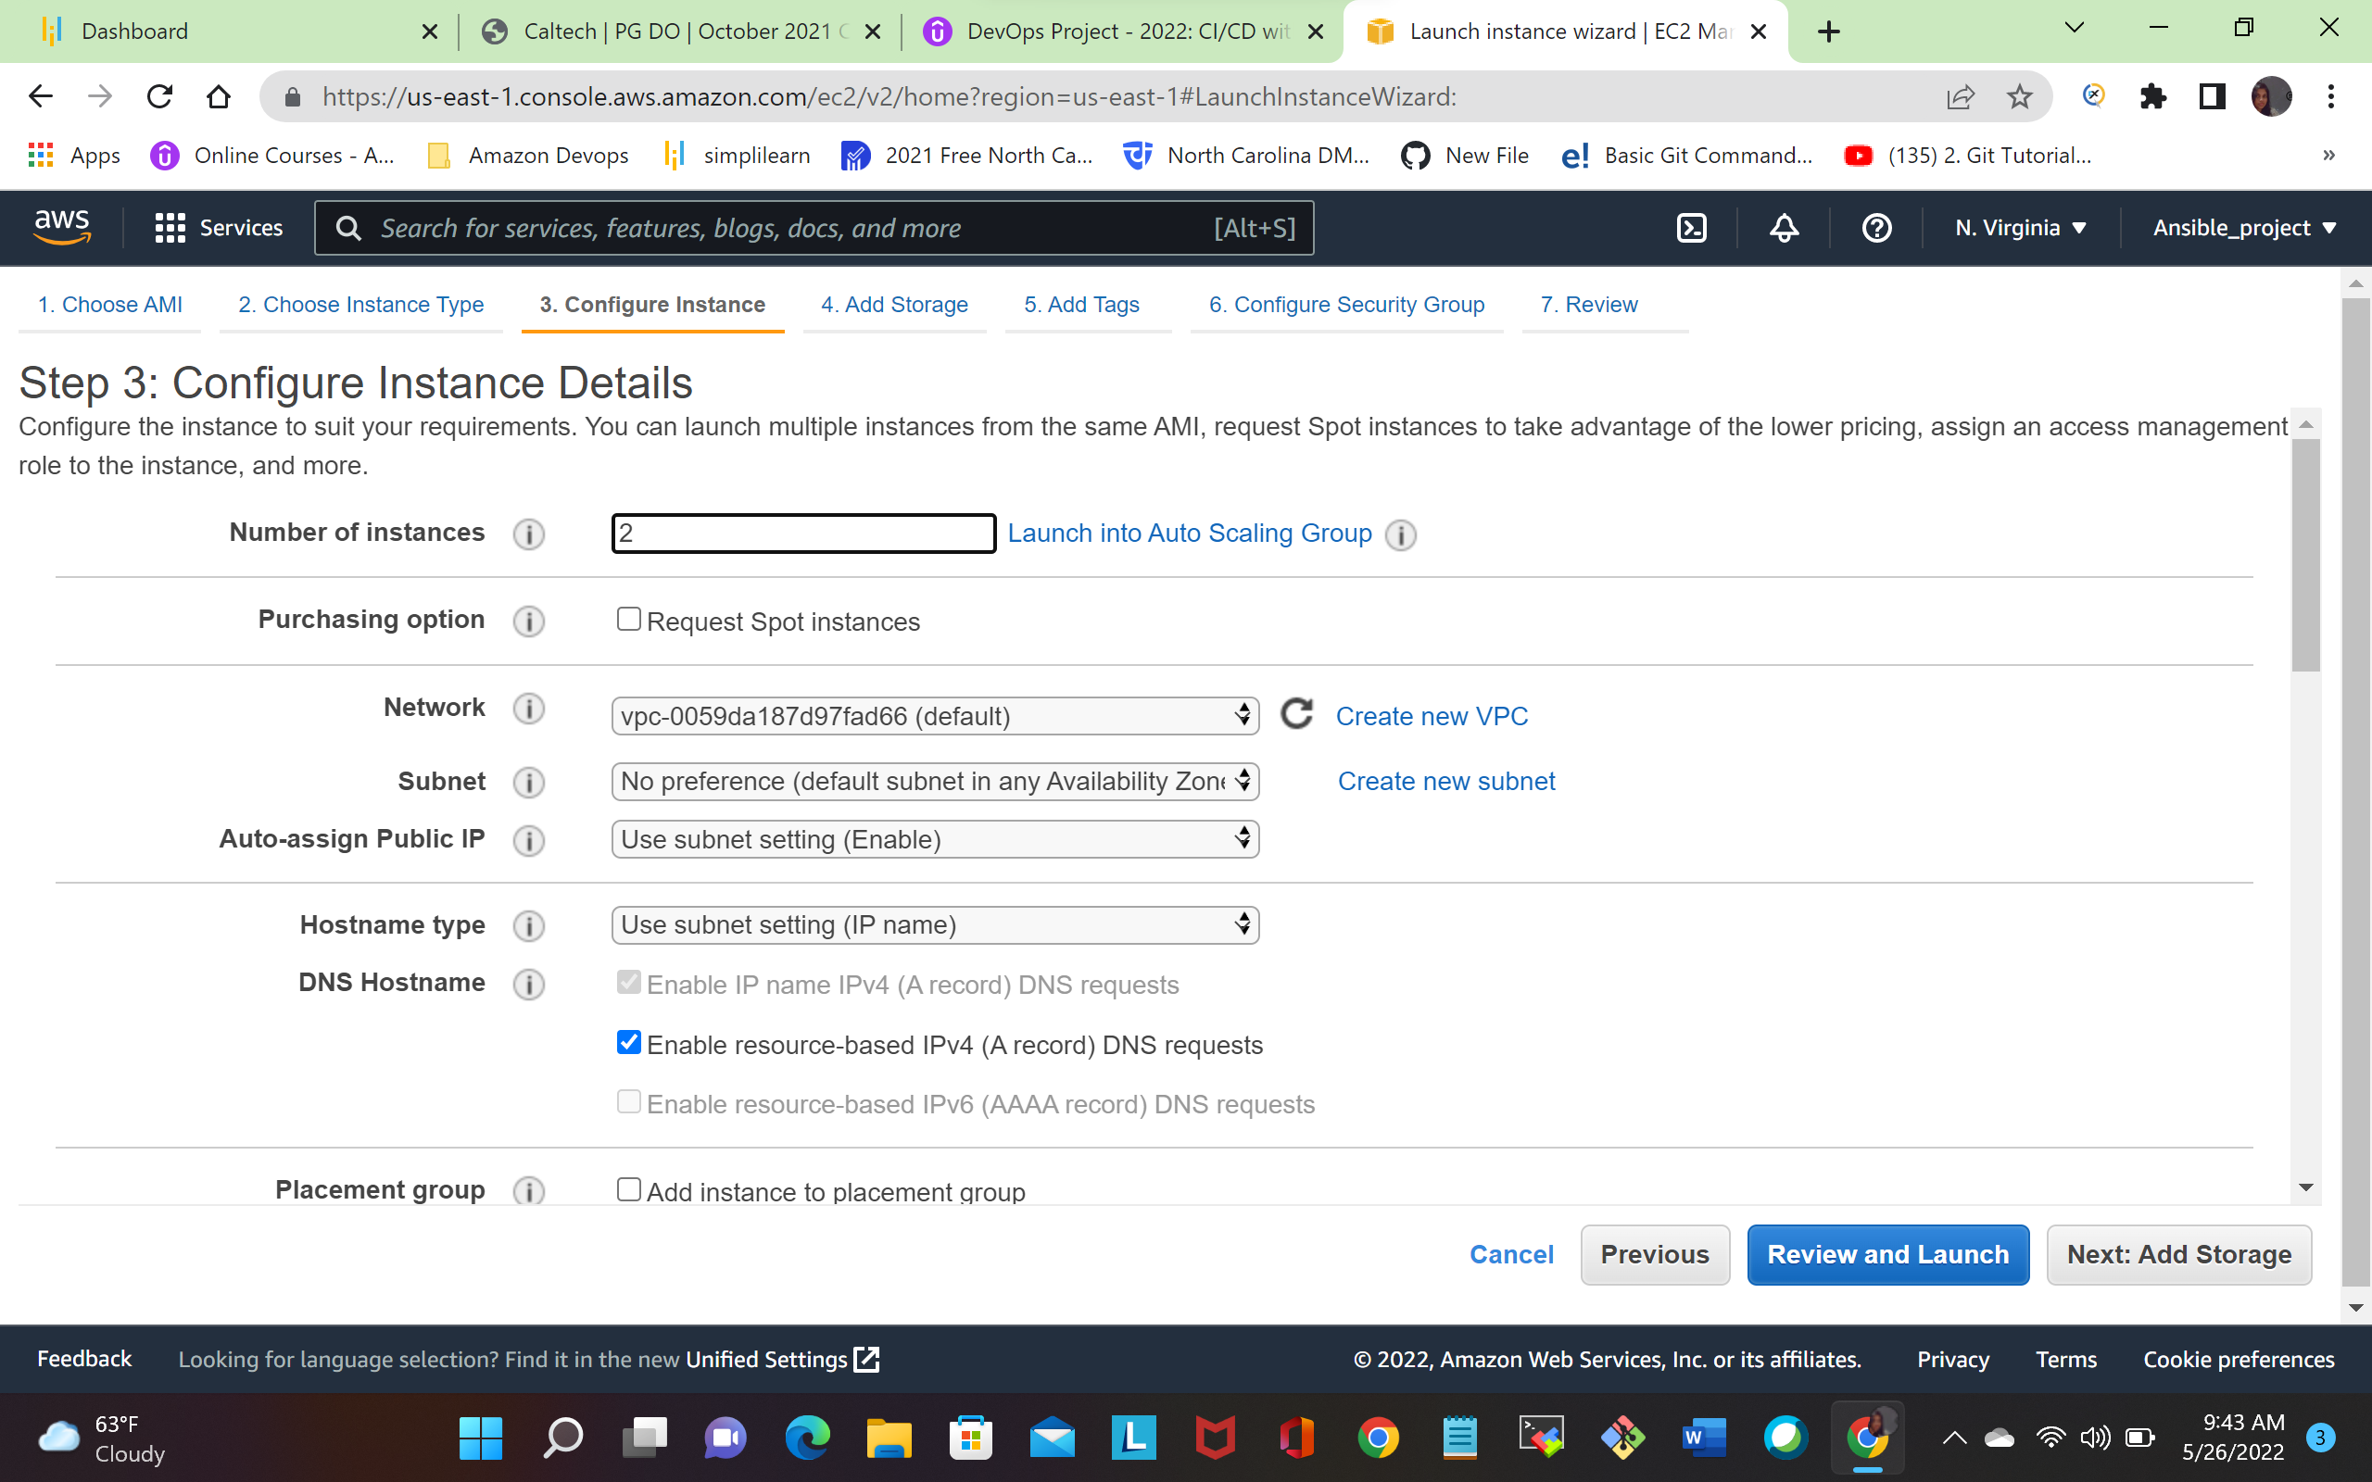

### **Step 6: Add Storage of Ec2 Instance**

In this step, I chose storage. By default, ec2 t2-micro provide 8gb ssd. Shown in the below picture:

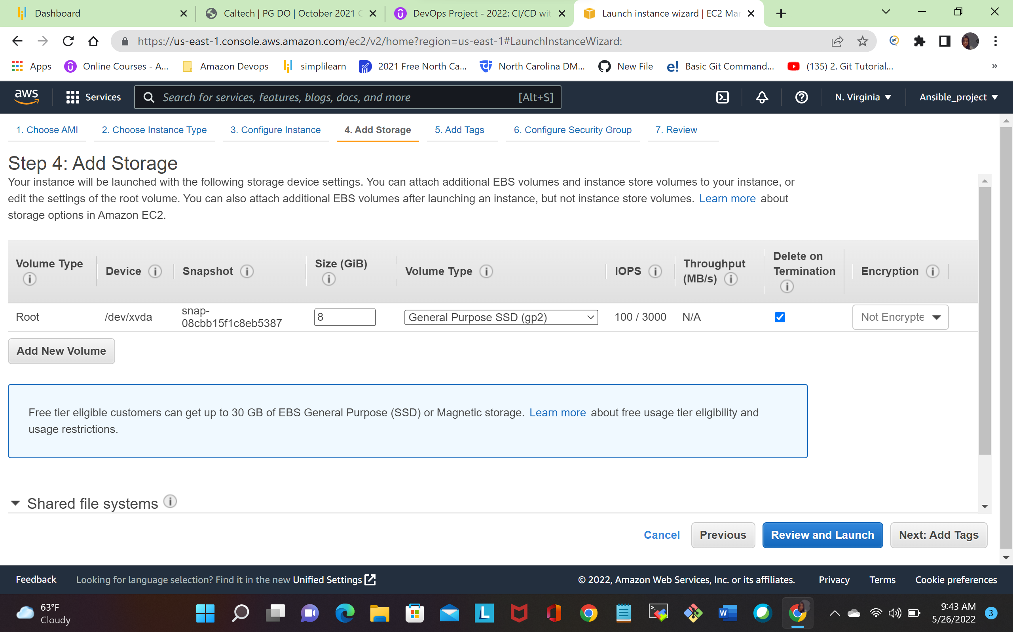

### **Step 7: Tag Instance of Ec2 Instance**

In this step, I added tag of instance with a key-value pair.

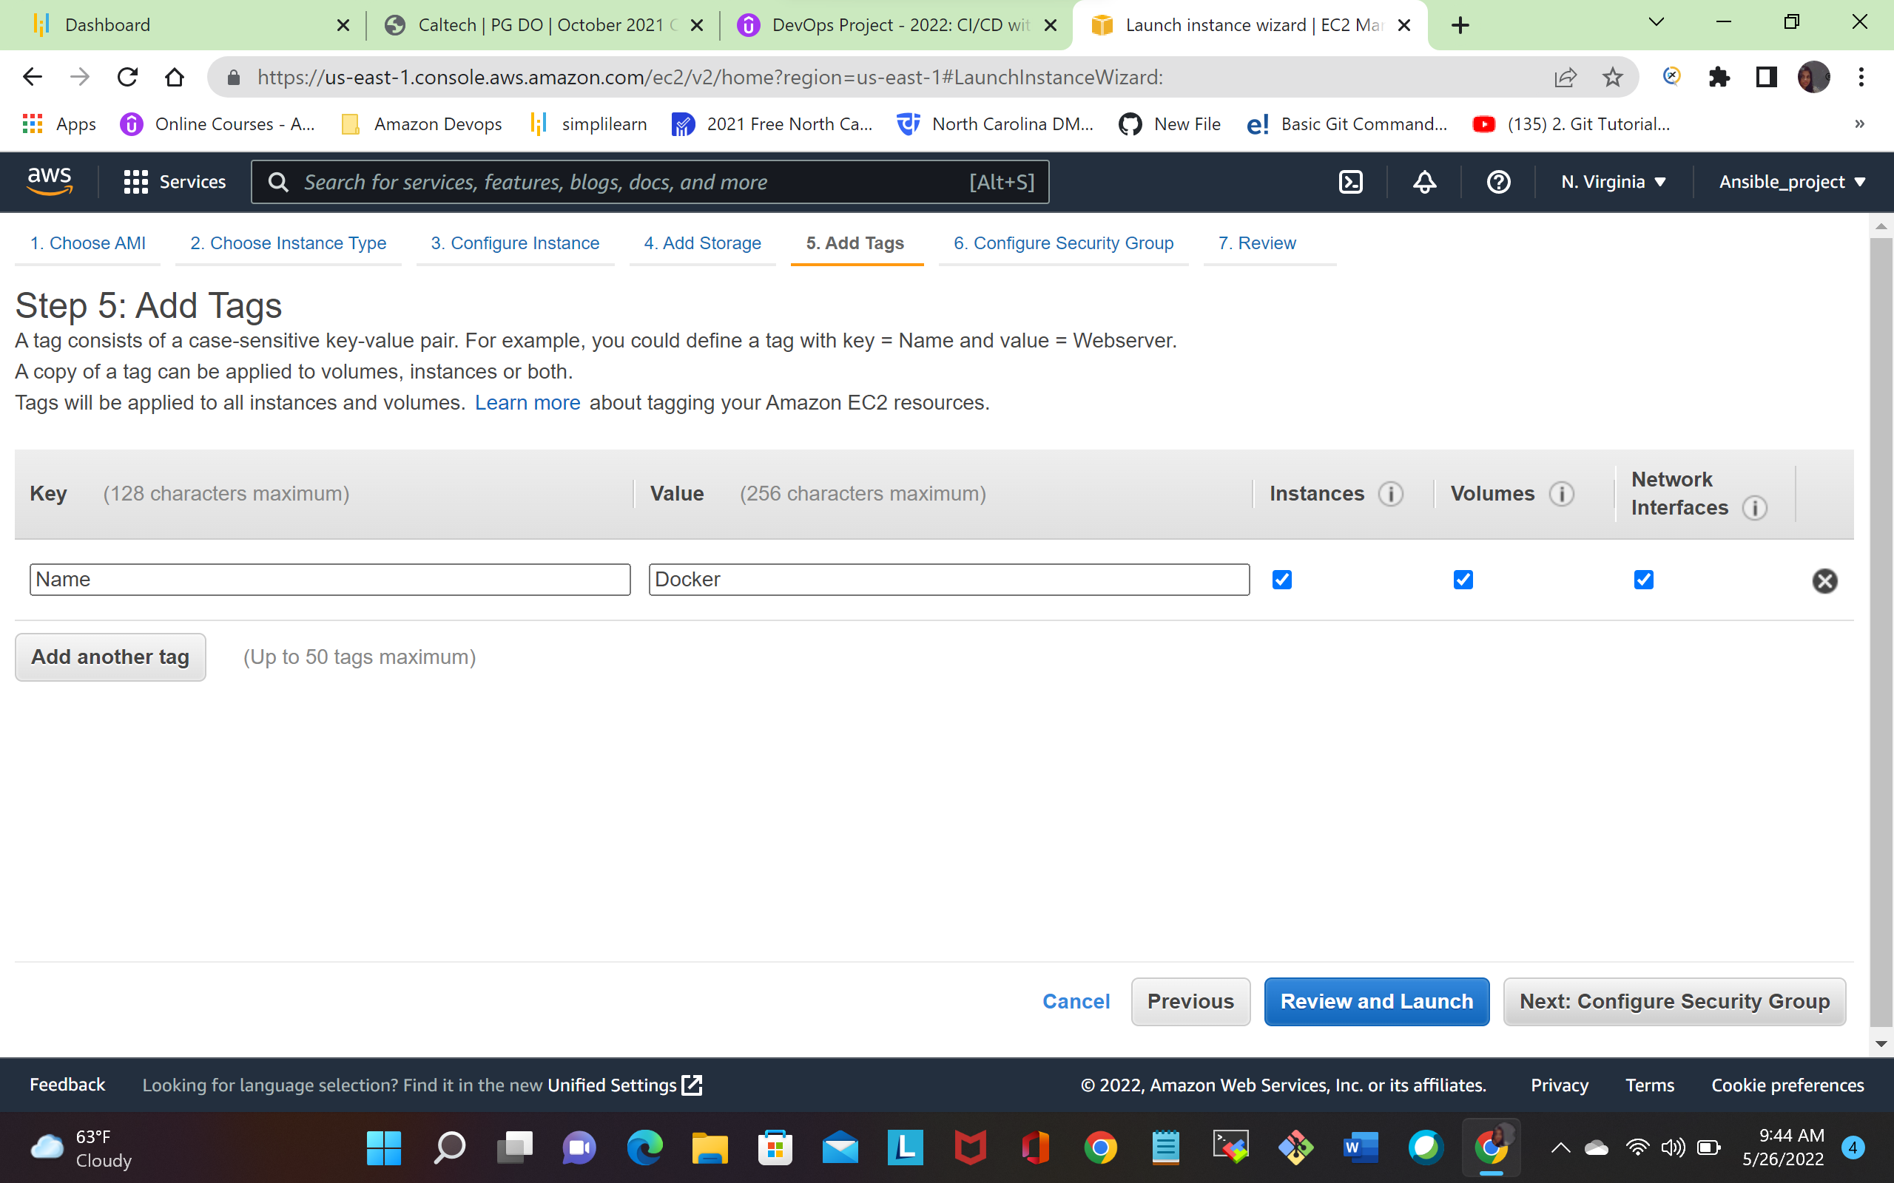

### **Step 8: Configure Security Groups**

In this next step of configuring Security Groups

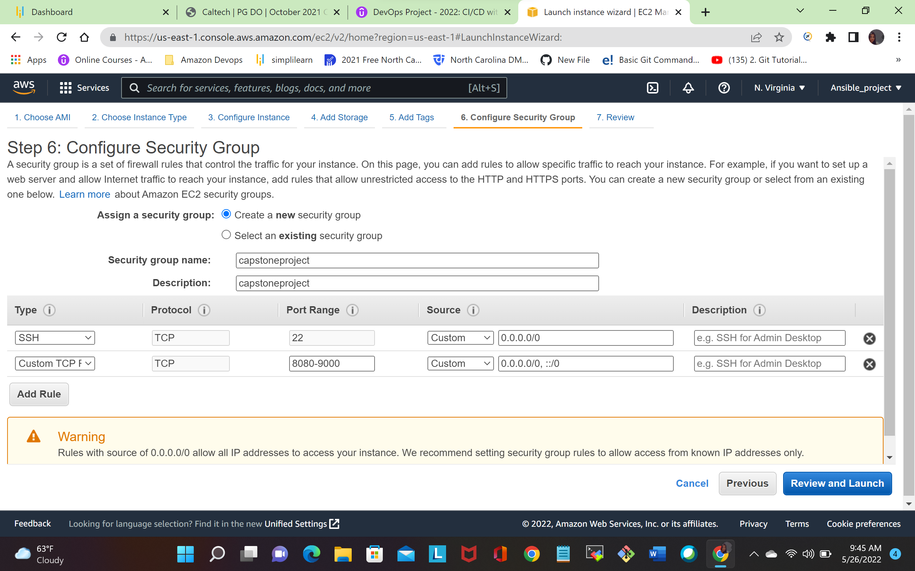

I created security group called capstone project and Defining protocols which i want enabled on my instance

**Step 9: Once**, the firewall rules are set- **Review and launch**

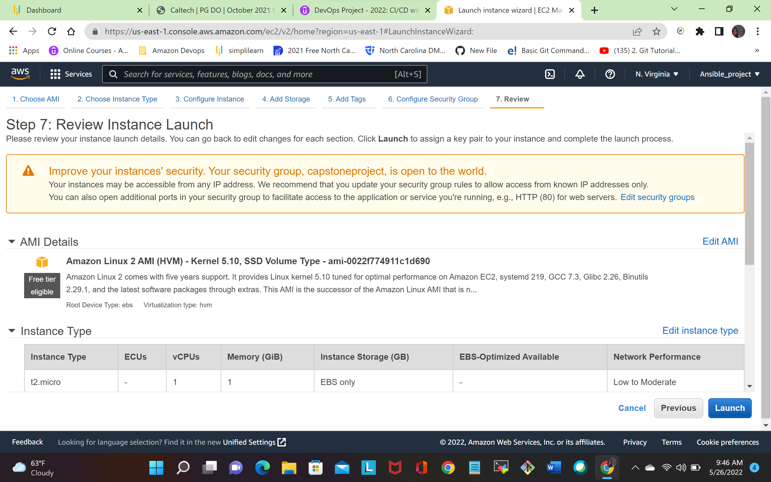

### **Step 10: Create Key-Pair for Instance Access:**

Creating a keypair for ec2 instance, (I used existing keypair) create new key pair and add the name of this key. Then download and save it in your secured folder. Shown in below fig

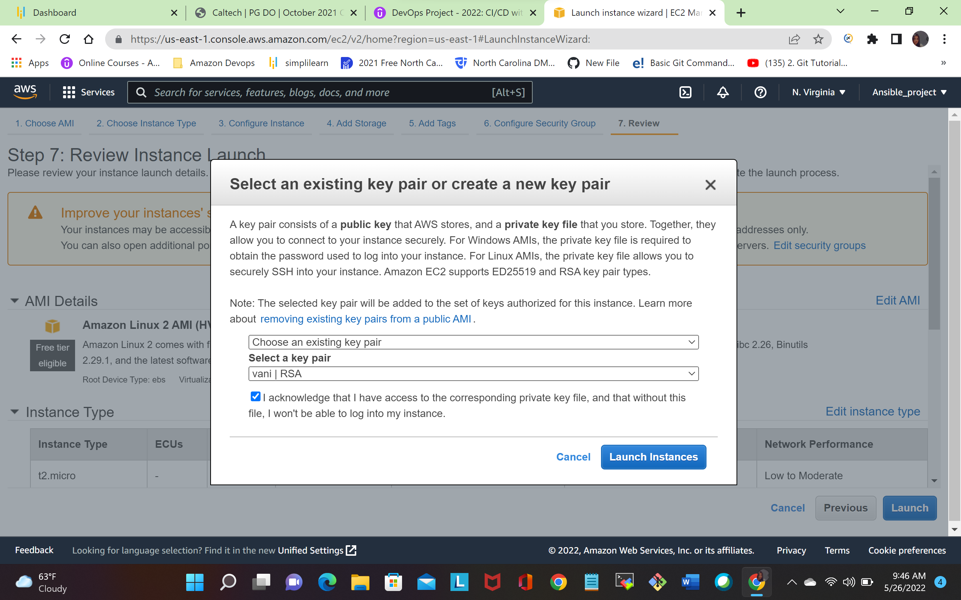

# **Use pem file in MobaXterm to connect ec2 machine in AWS:-**

I used MobaXterm to connect ec2 machine. I downloaded mobaxterm .go to the session settings to create a new session, fill up the remote host and username.

And click advance setting and select use private key, select your private key

As shown in the below fig

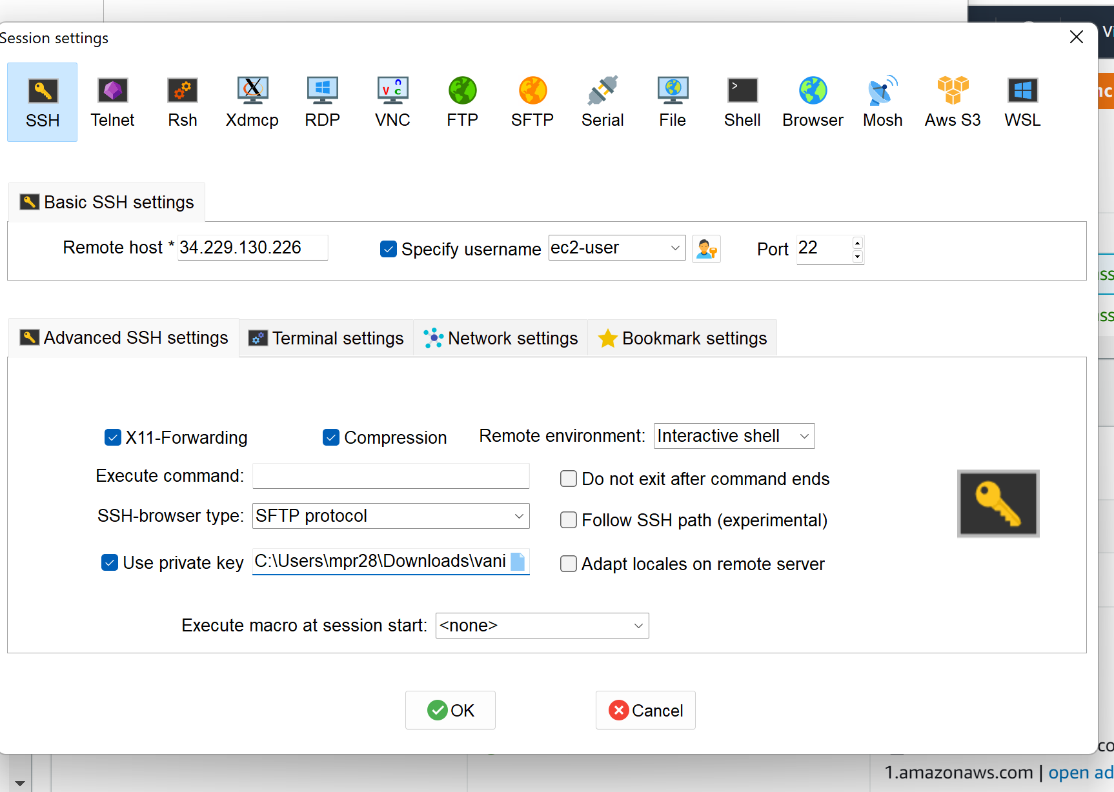

**After clicking ok it taking into page shown in below fig**

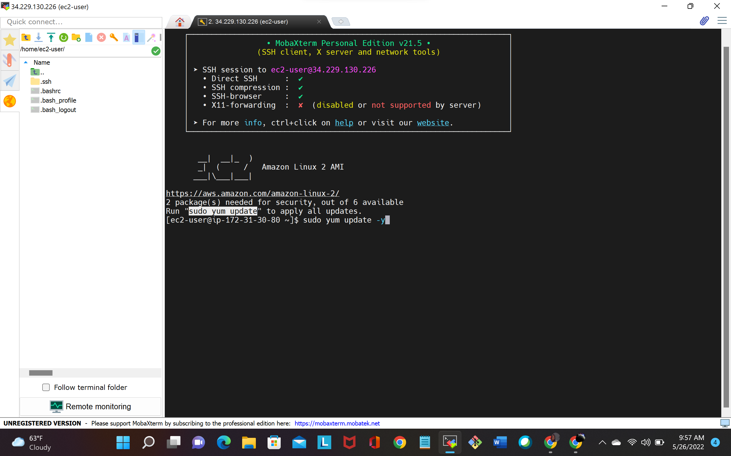

I created two ec2 instance machine (Jenkins and dockerservice )

**Install Docker on the dockerservice(EC2 Instance) Start docker services:**

The following command can be used to install docker

**yum install docker –y**

docker --version   
  
**# Start docker services**  
**service docker start**  
**service docker status**

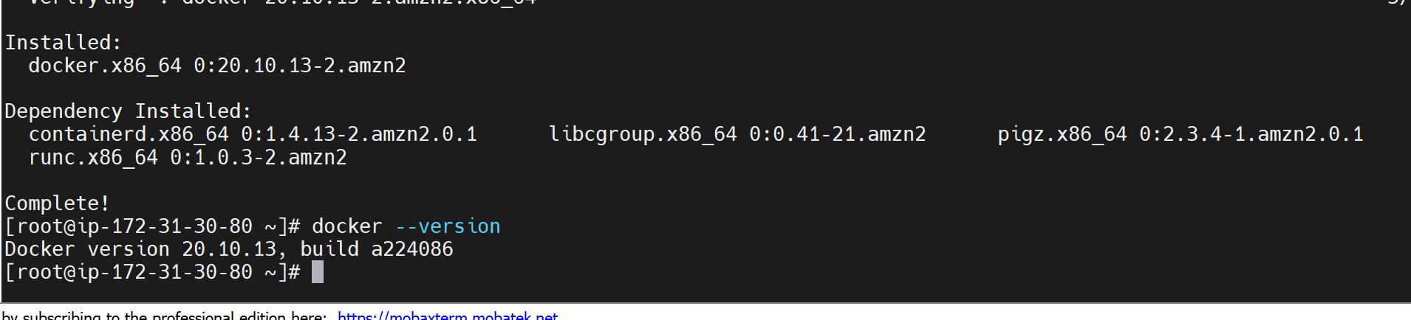**Creating a user**:

I created user called dockeradmin. using following commands

**useradd dockeradmin**  
**passwd dockeradmin**. Shown in below fig

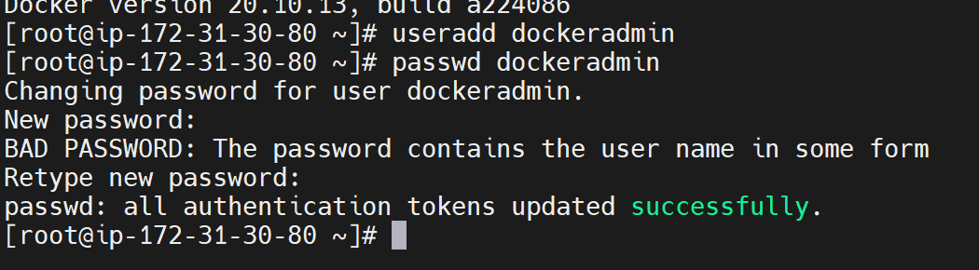

**Add a user to docker group to manage docker: -**

I added a user in docker group using following command

**usermod -aG docker dockeradmin**

### **Adding Users to Sudoers File:**

Next step is to add dockeradmin user into sudoers file using following commands

|  |
| --- |
| **sudo visudo**  Shown in the following fig |

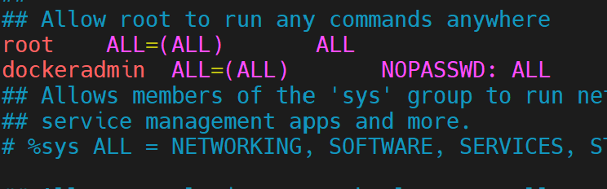

The place where you see root ALL=(ALL:ALL) ALL, that’s where we’ll be amending our user name. And next use following command to configure sshd_config file to enable password less authentication, show in the following

* **Enable Password Authentication in below File Path**  
   **vi /etc/ssh/sshd_config**. uncomment the password authentication and change **no** to **yes**

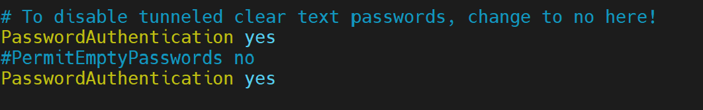

* **Reload Service with the command service sshd reload**

And I followed same steps in Jenkins server to add user and enable password less authentication.

Next steps are to create a connection between docker machine and Jenkins by downloading sshkey ,using following command .login as a dockeradmin using following command

**sudo su - dockeradmin**

**And generate sshkey using command ssh-keygen**

* **After generating I copied the public key to Jenkins server using following command ssh-copy-id dockeradmin@ 172.31.28.201 (**ssh-copy-id user@<target-server> - Authorized_keys)

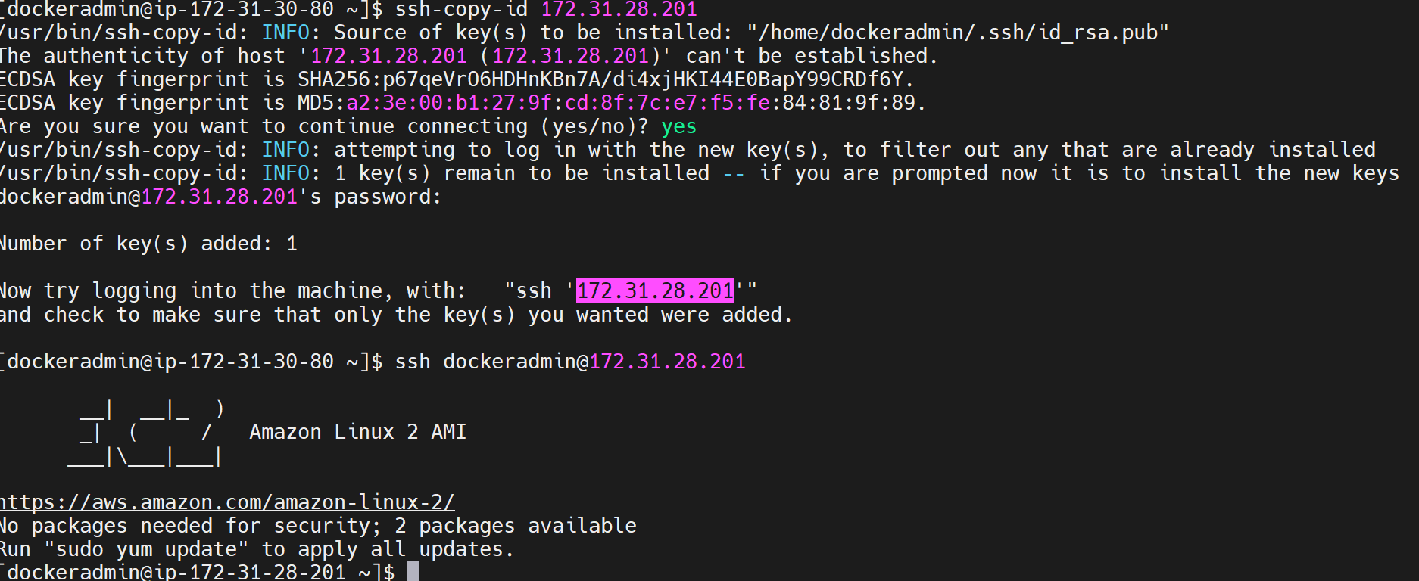

**And next step is to configured Jenkins server to install jenkins,maven,git**

#### **Install Git on Jenkins server**

Using following command

**yum install git -y**

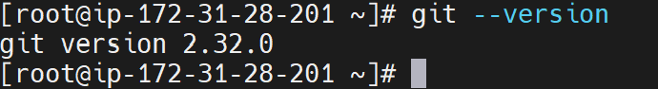

**Install maven**

Download maven packages <https://maven.apache.org/download.cgi> onto Jenkins server. In this case, I am using /opt/maven as my installation directory



And I used following command to move maven to opt directory

**cp –R apache-maven-3.8.5 /opt**

**I used wget command to download maven (wget is used to download files from an HTTP/HTTPS or FTP server)**

**wget** [**https://dlcdn.apache.org/maven/maven-3/3.8.5/binaries/apache-maven-3.8.5-bin.tar.gz**](https://dlcdn.apache.org/maven/maven-3/3.8.5/binaries/apache-maven-3.8.5-bin.tar.gz)

**Next step is to extract the archive using following command**

**tar xzvf apache-maven-3.8.5-bin.tar.gz**

**Maven home path in bash profile**

**JAVA_HOME=/usr/lib/jvm/java-1.8.0-openjdk-1.8.0.312.b07-1.amzn2.0.2.x86_64**

**MAVEN_HOME=/opt/apache-maven-3.8.5**

**M2=/opt/apache-maven-3.8.5/bin**

**PATH=$****PATH:$HOME/****bin:$JAVA_****HOME:$MAVEN_****HOME:$M2**

**Download Java**  
<http://openjdk.java.net/install/>

**Install Java in Linux**

**yum install java-1.8.0-openjdk-devel**

**Java is installed in usr/lib directory**

**Set Java Home Path in Bash profile**

**JAVA_HOME=/usr/lib/jvm/java-1.8.0-openjdk-1.8.0.312.b07-1.amzn2.0.2.x86_64**

**PATH=$****PATH:$HOME/****bin:$JAVA_HOME:**

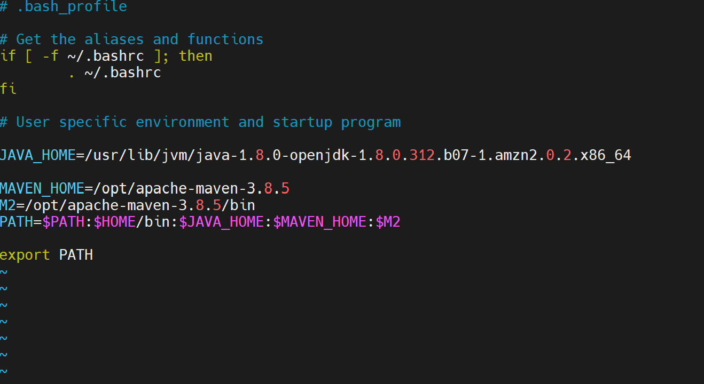

**Install Jenkins:-**

**install Jenkins using the rpm or by setting up the repo**

I downloaded the latest Version of Jenkins form <https://pkg.jenkins.io/redhat-stable/> and install

**sudo wget -O /etc/yum.repos.d/jenkins.repo** [**https://pkg.jenkins.io/redhat-stable/jenkins.repo**](https://pkg.jenkins.io/redhat-stable/jenkins.repo)**sudo rpm --import https://pkg.jenkins.io/redhat-stable/jenkins.io.key**  
**amazon-linux-extras install epel**  
**after downloading Start the Jenkins services using following command**

**Service jenkins start**

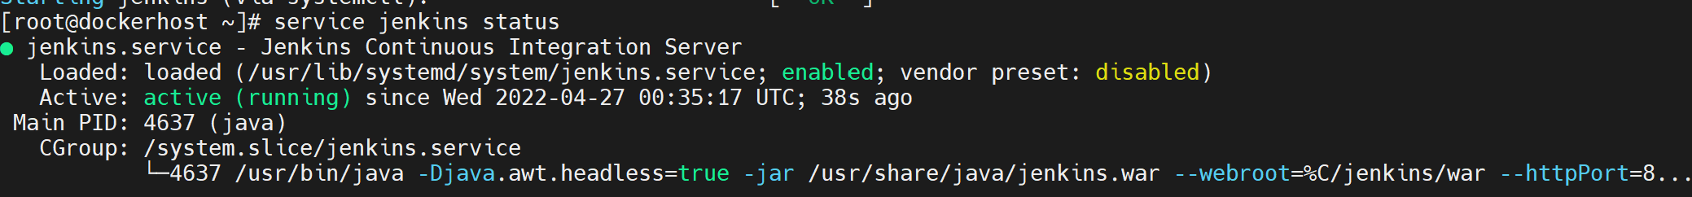

### **Accessing Jenkins**

By default, jenkins runs at port 8080, You can access jenkins at

<http://YOUR-SERVER-PUBLIC-IP:8080>

**Configure Jenkins:**

Grab the default password

Password Location:/var/lib/jenkins/secrets/initialAdminPassword

Paste it. Shown in below fig

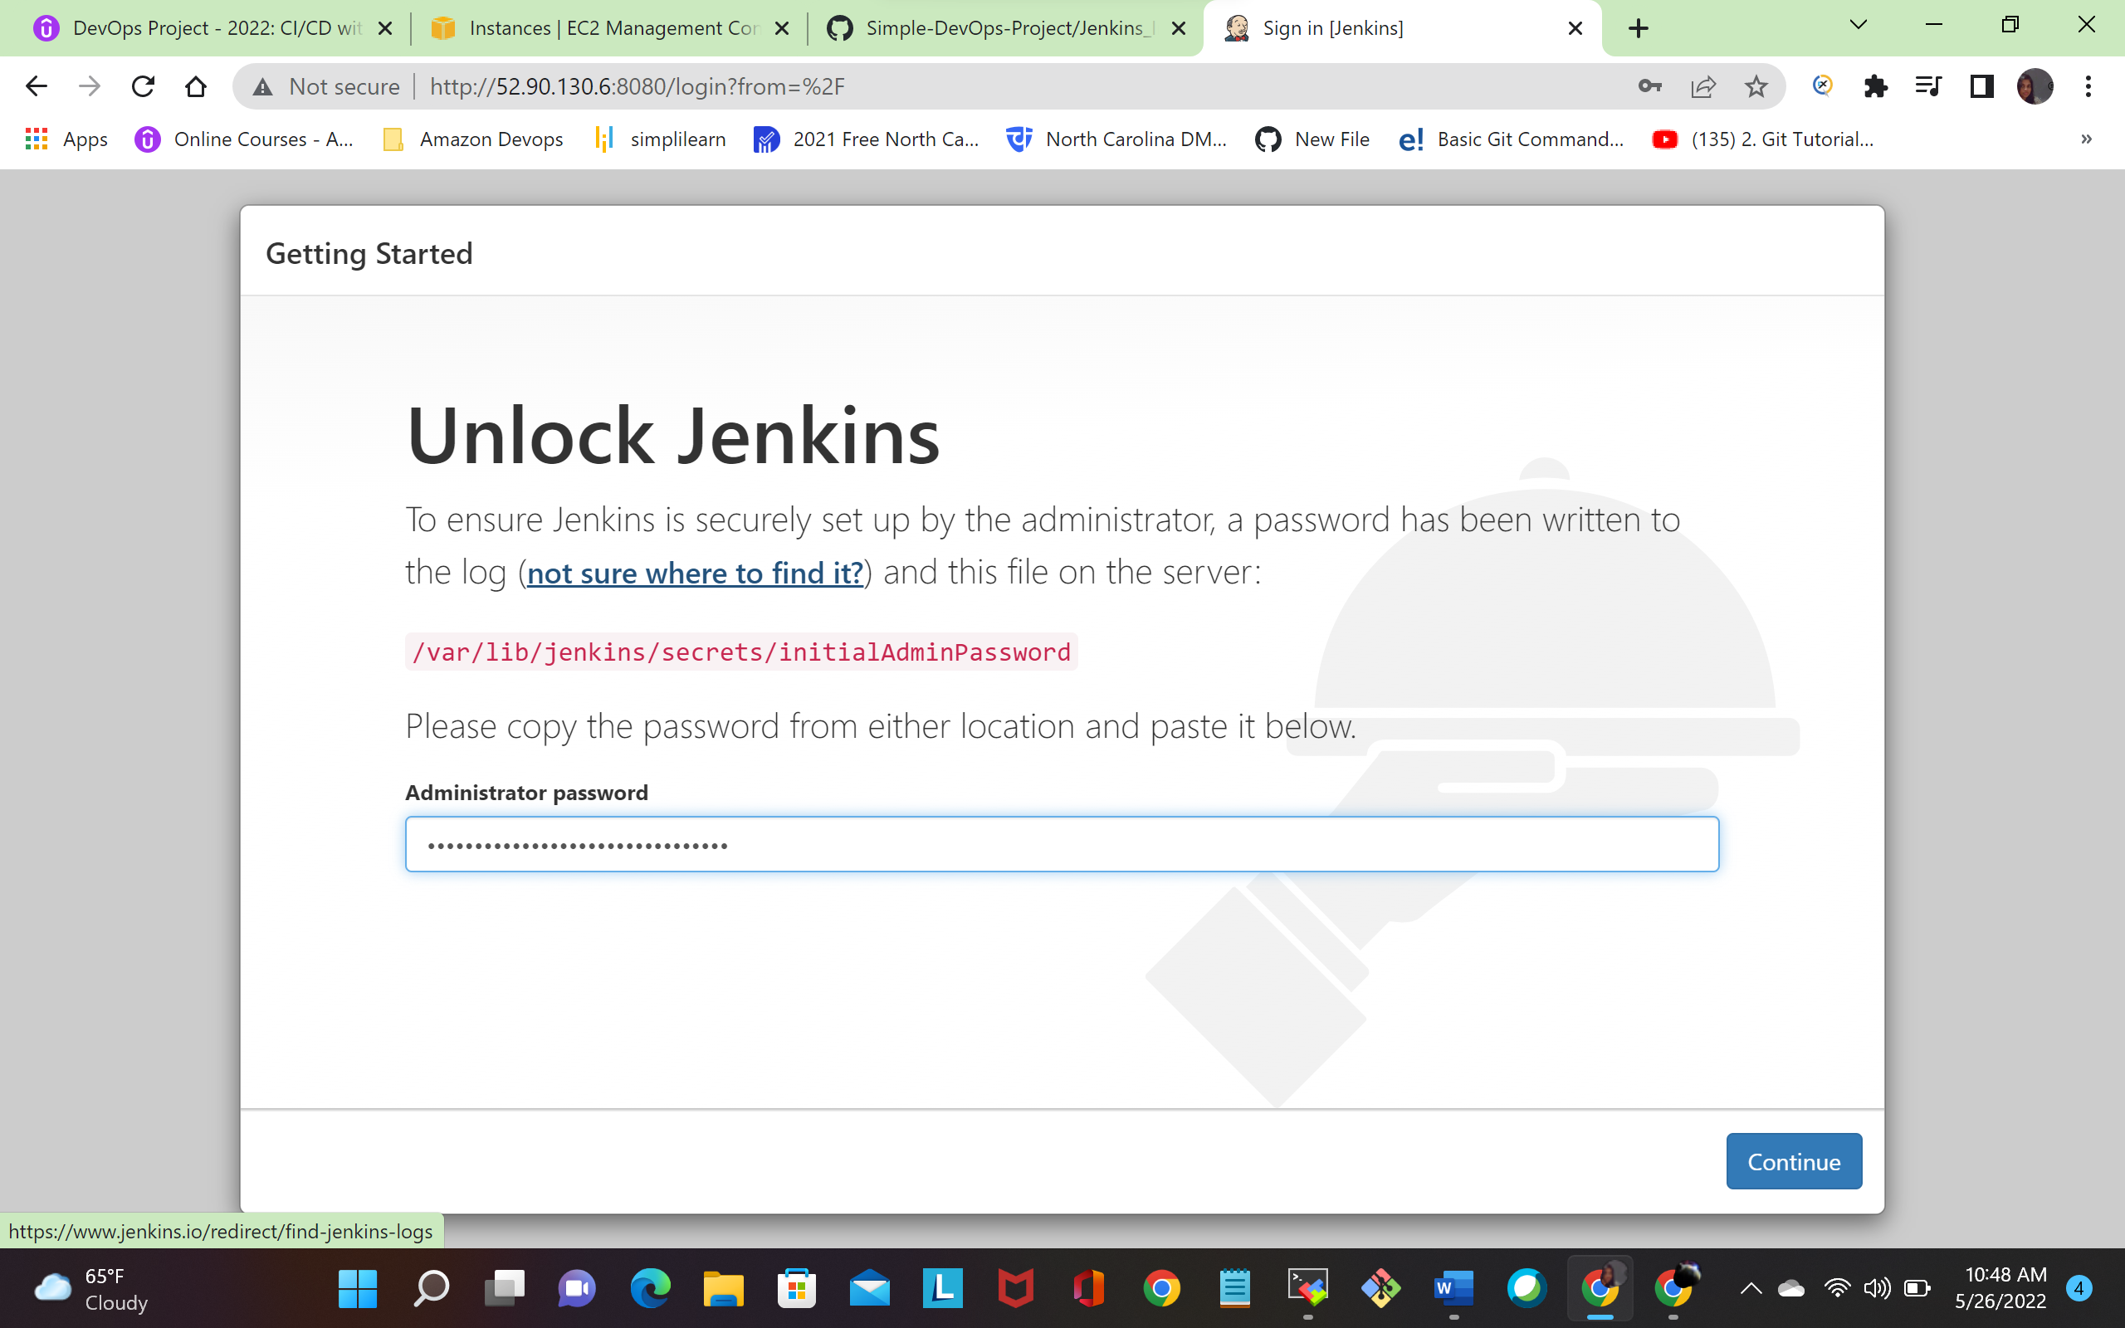

Choose suggested plugins. Shown in below fig

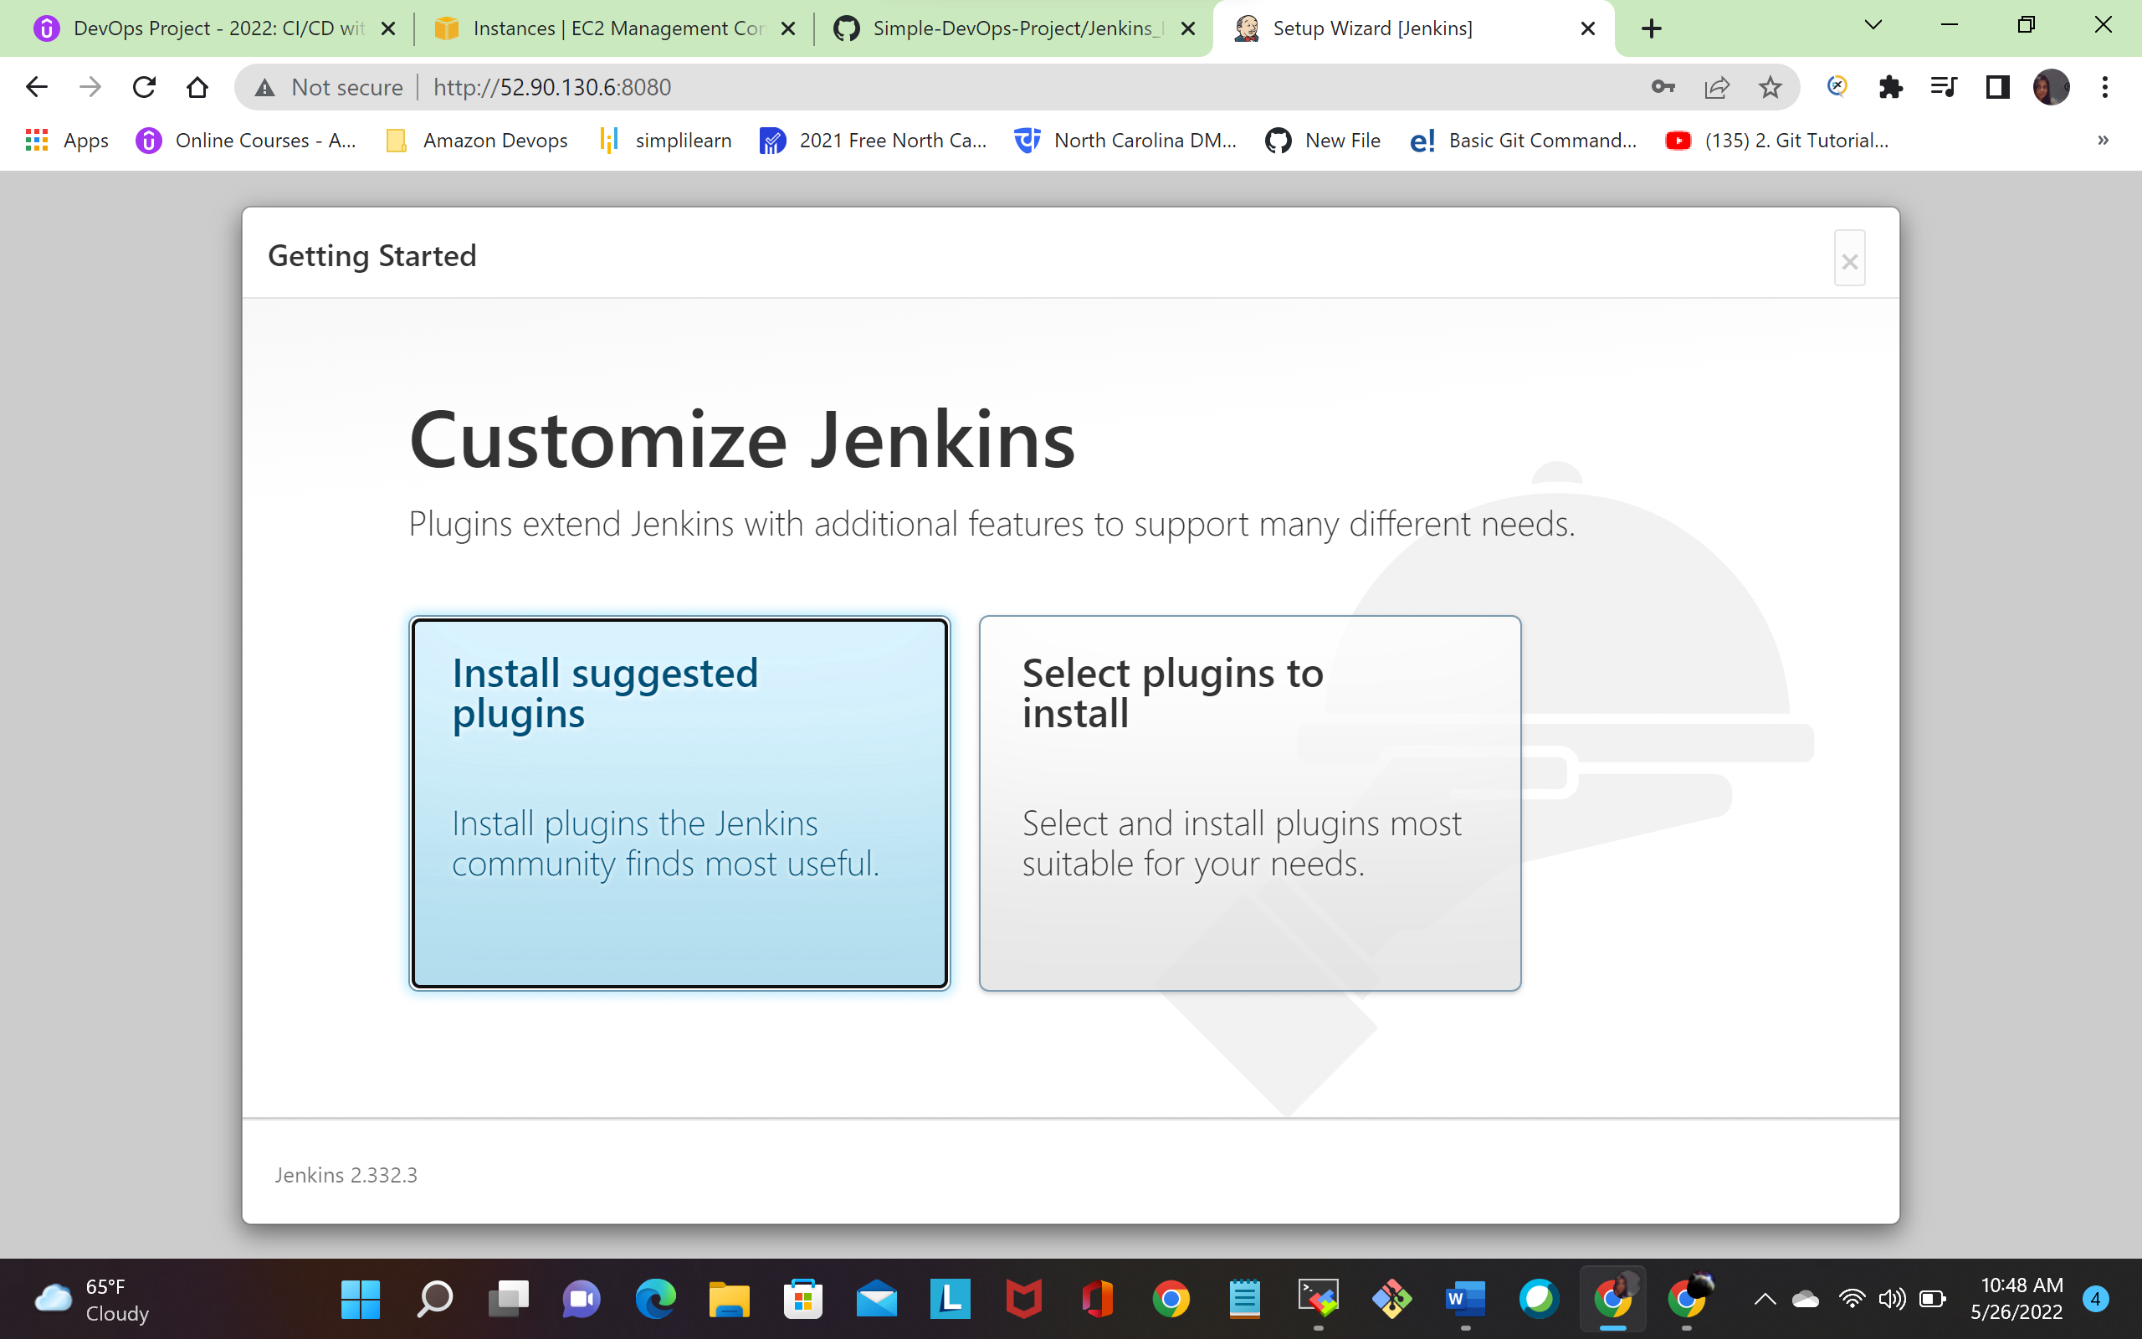

**And enter username, password email address shown in below fig**

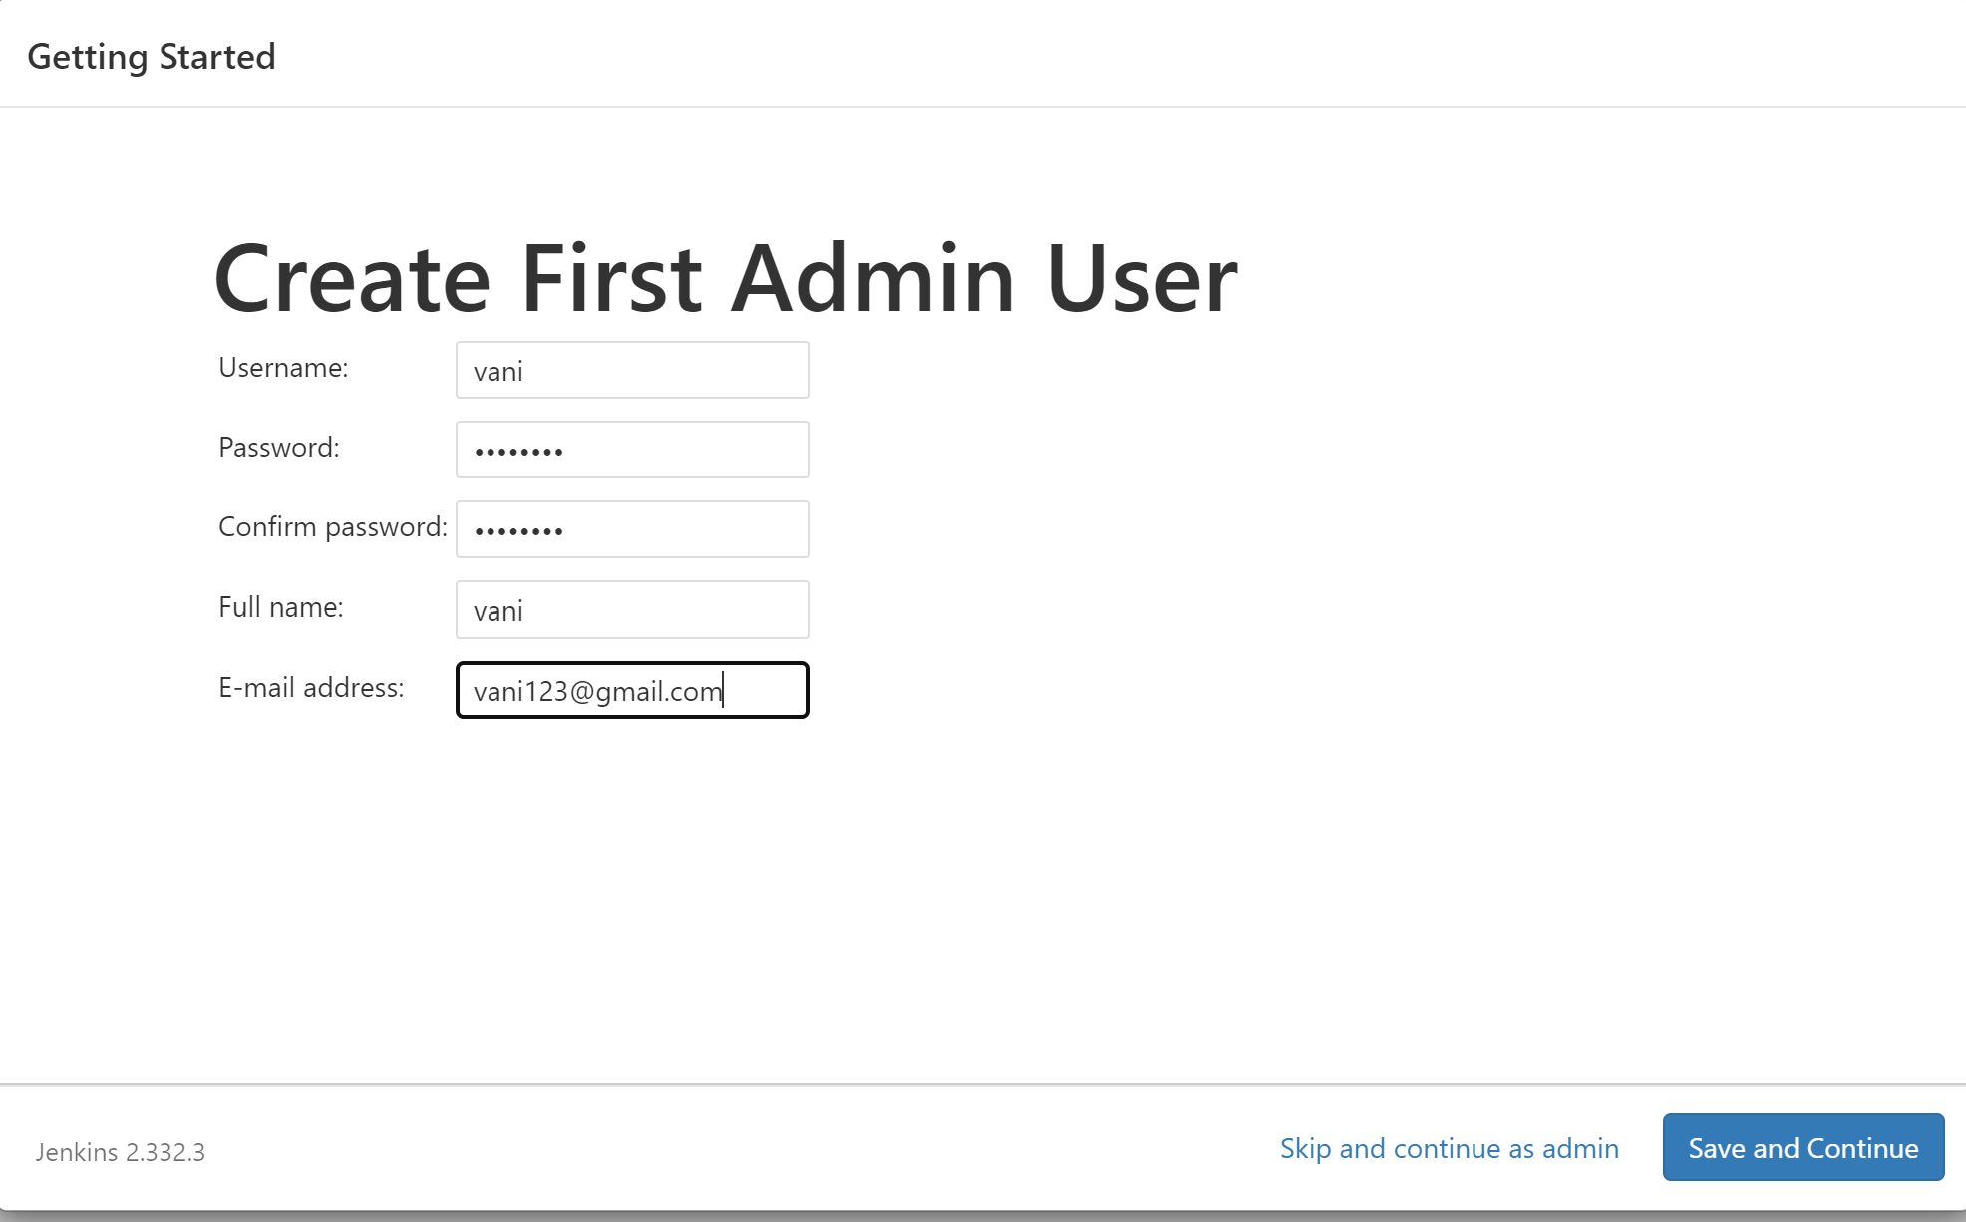

Click save and continue.it taken you into jenkins dashboard

**Jenkins Dashboard: -**

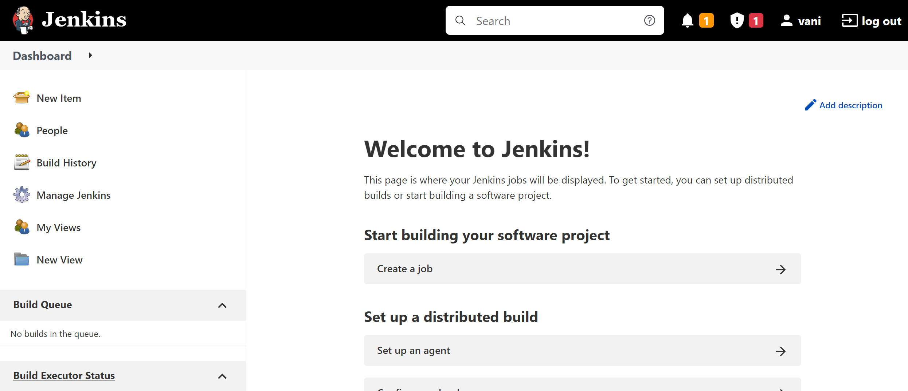

**Configure java and maven path**

**Manage Jenkins > Global Tool Configuration > JDK**

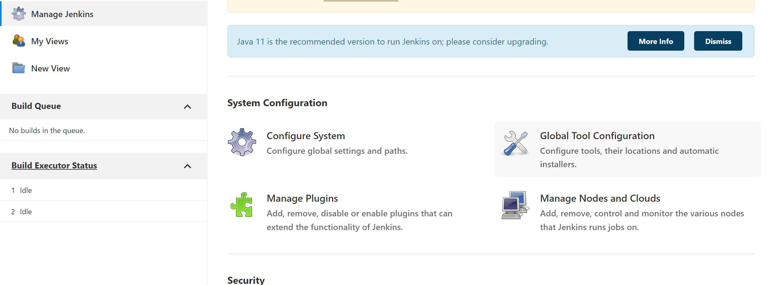

Click add JDK and give JDK name as JAVA_HOME and path of JDK

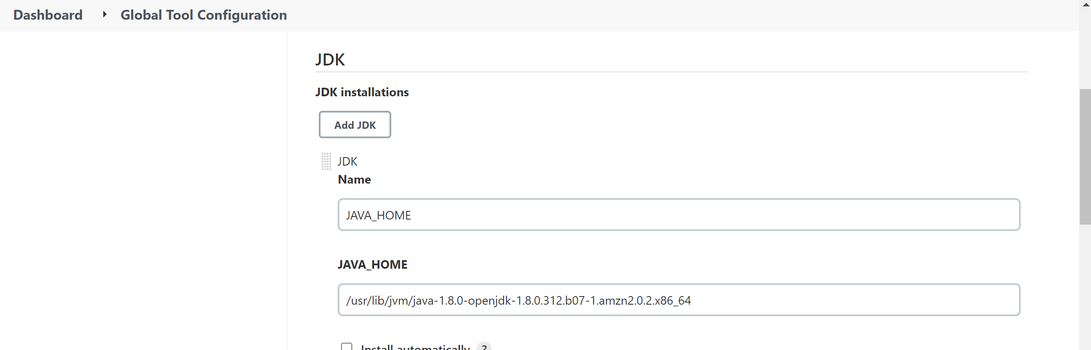

**Next configure maven path, click maven give name for maven as MAVEN_HOME And path of maven**

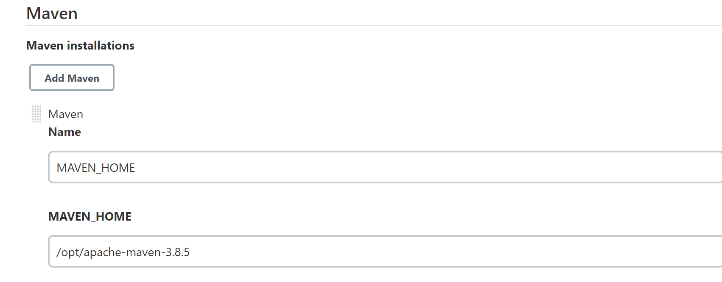

After finishing all configure setting we are going to push the docker image into docker hub using jenkins:

# **Publish Docker image to Dockerhub using Jenkins: -**

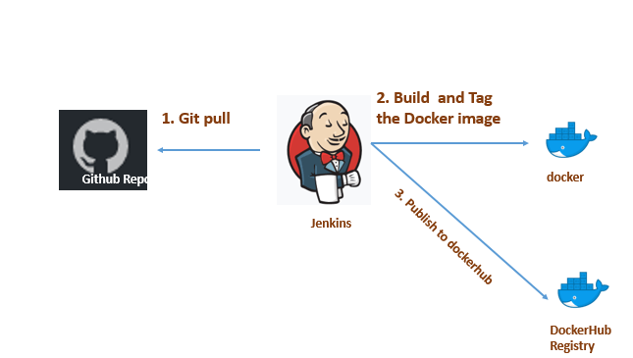

For creating docker image we need to write a **Dockerfile.go to the docker server, login as dockeradmin user using following command**

**sudo su – dockeradmin**

**Create a dockerfile using vi editor**

**This file explains that Docker file which can pull Tomcat Image and perform necessary configurations to deploy war file**

**vi Dockerfile**

**FROM tomcat:latest**

**COPY ./webapp.war /usr/local/tomcat/webapps**

**RUN cp -r /usr/local/tomcat/webapps.dist/* /usr/local/tomcat/webapps**

Once docker file is created, push into GitHub

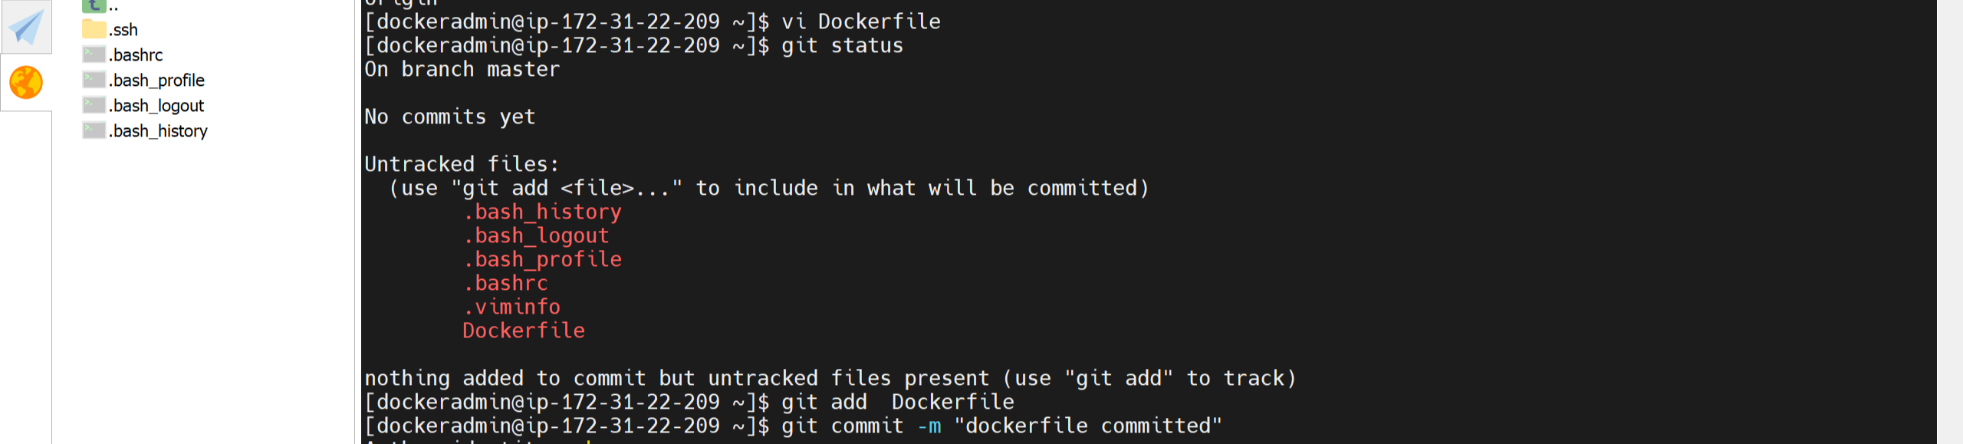

Now move to browser (browse http://YOUR-SERVER-PUBLIC-IP:8080) and configure jenkins

## **Setting Up Environment: -**

# **Install Maven Integration plugin, publish over ssh**

### This plugin is required to used integrate maven (maven integration) and publish over ssh is used to Send build artifacts over SSH.

Click on Manage Jenkins -> Manage Plugins-> search for maven integration and publish over ssh -> Install it without restart

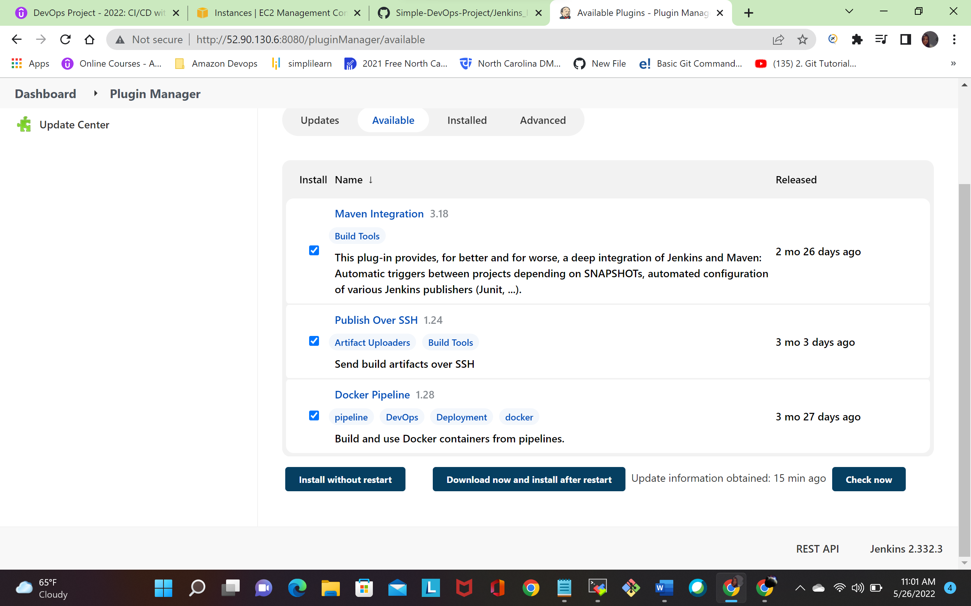

Click on Manage Jenkins ->system configuration-> ssh server and configure all the details shown in following fig

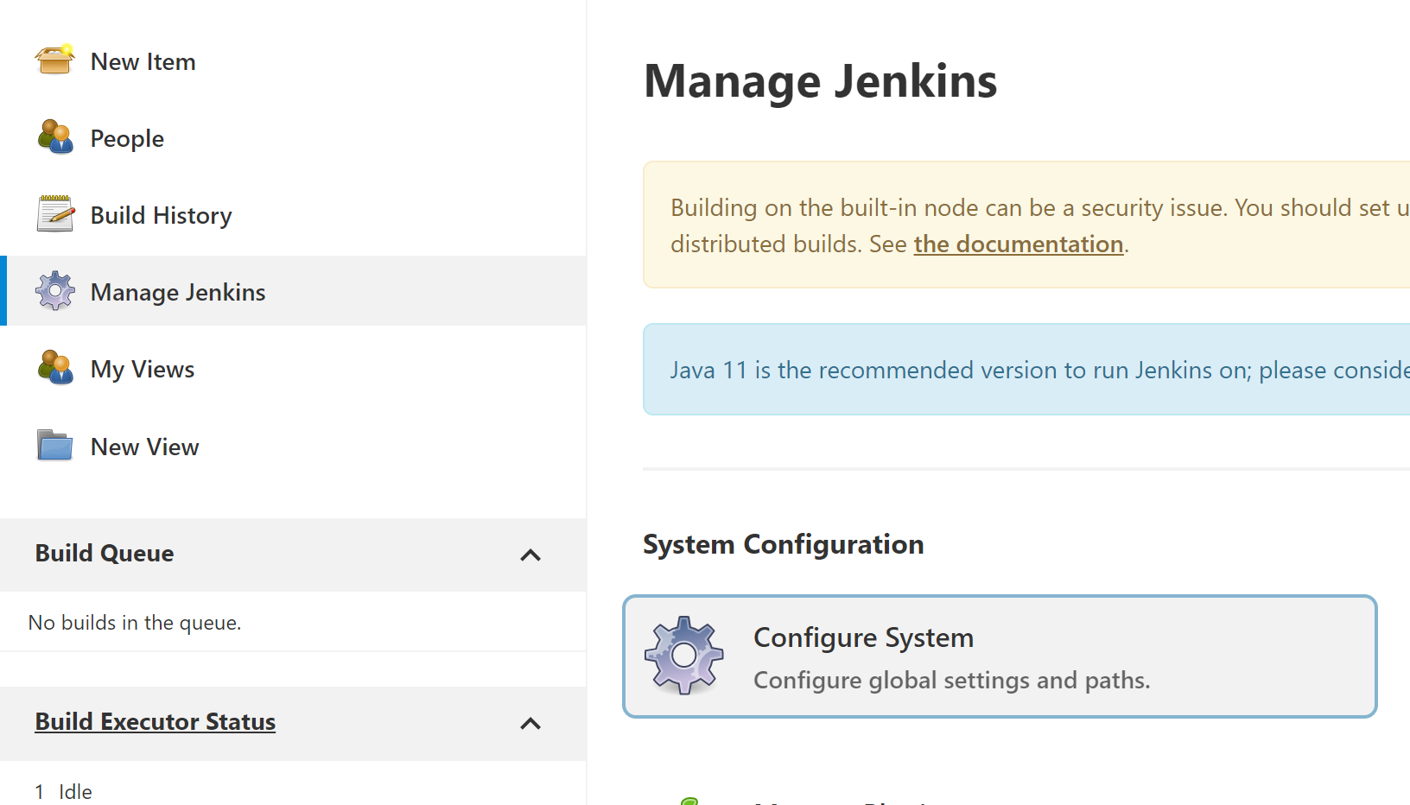

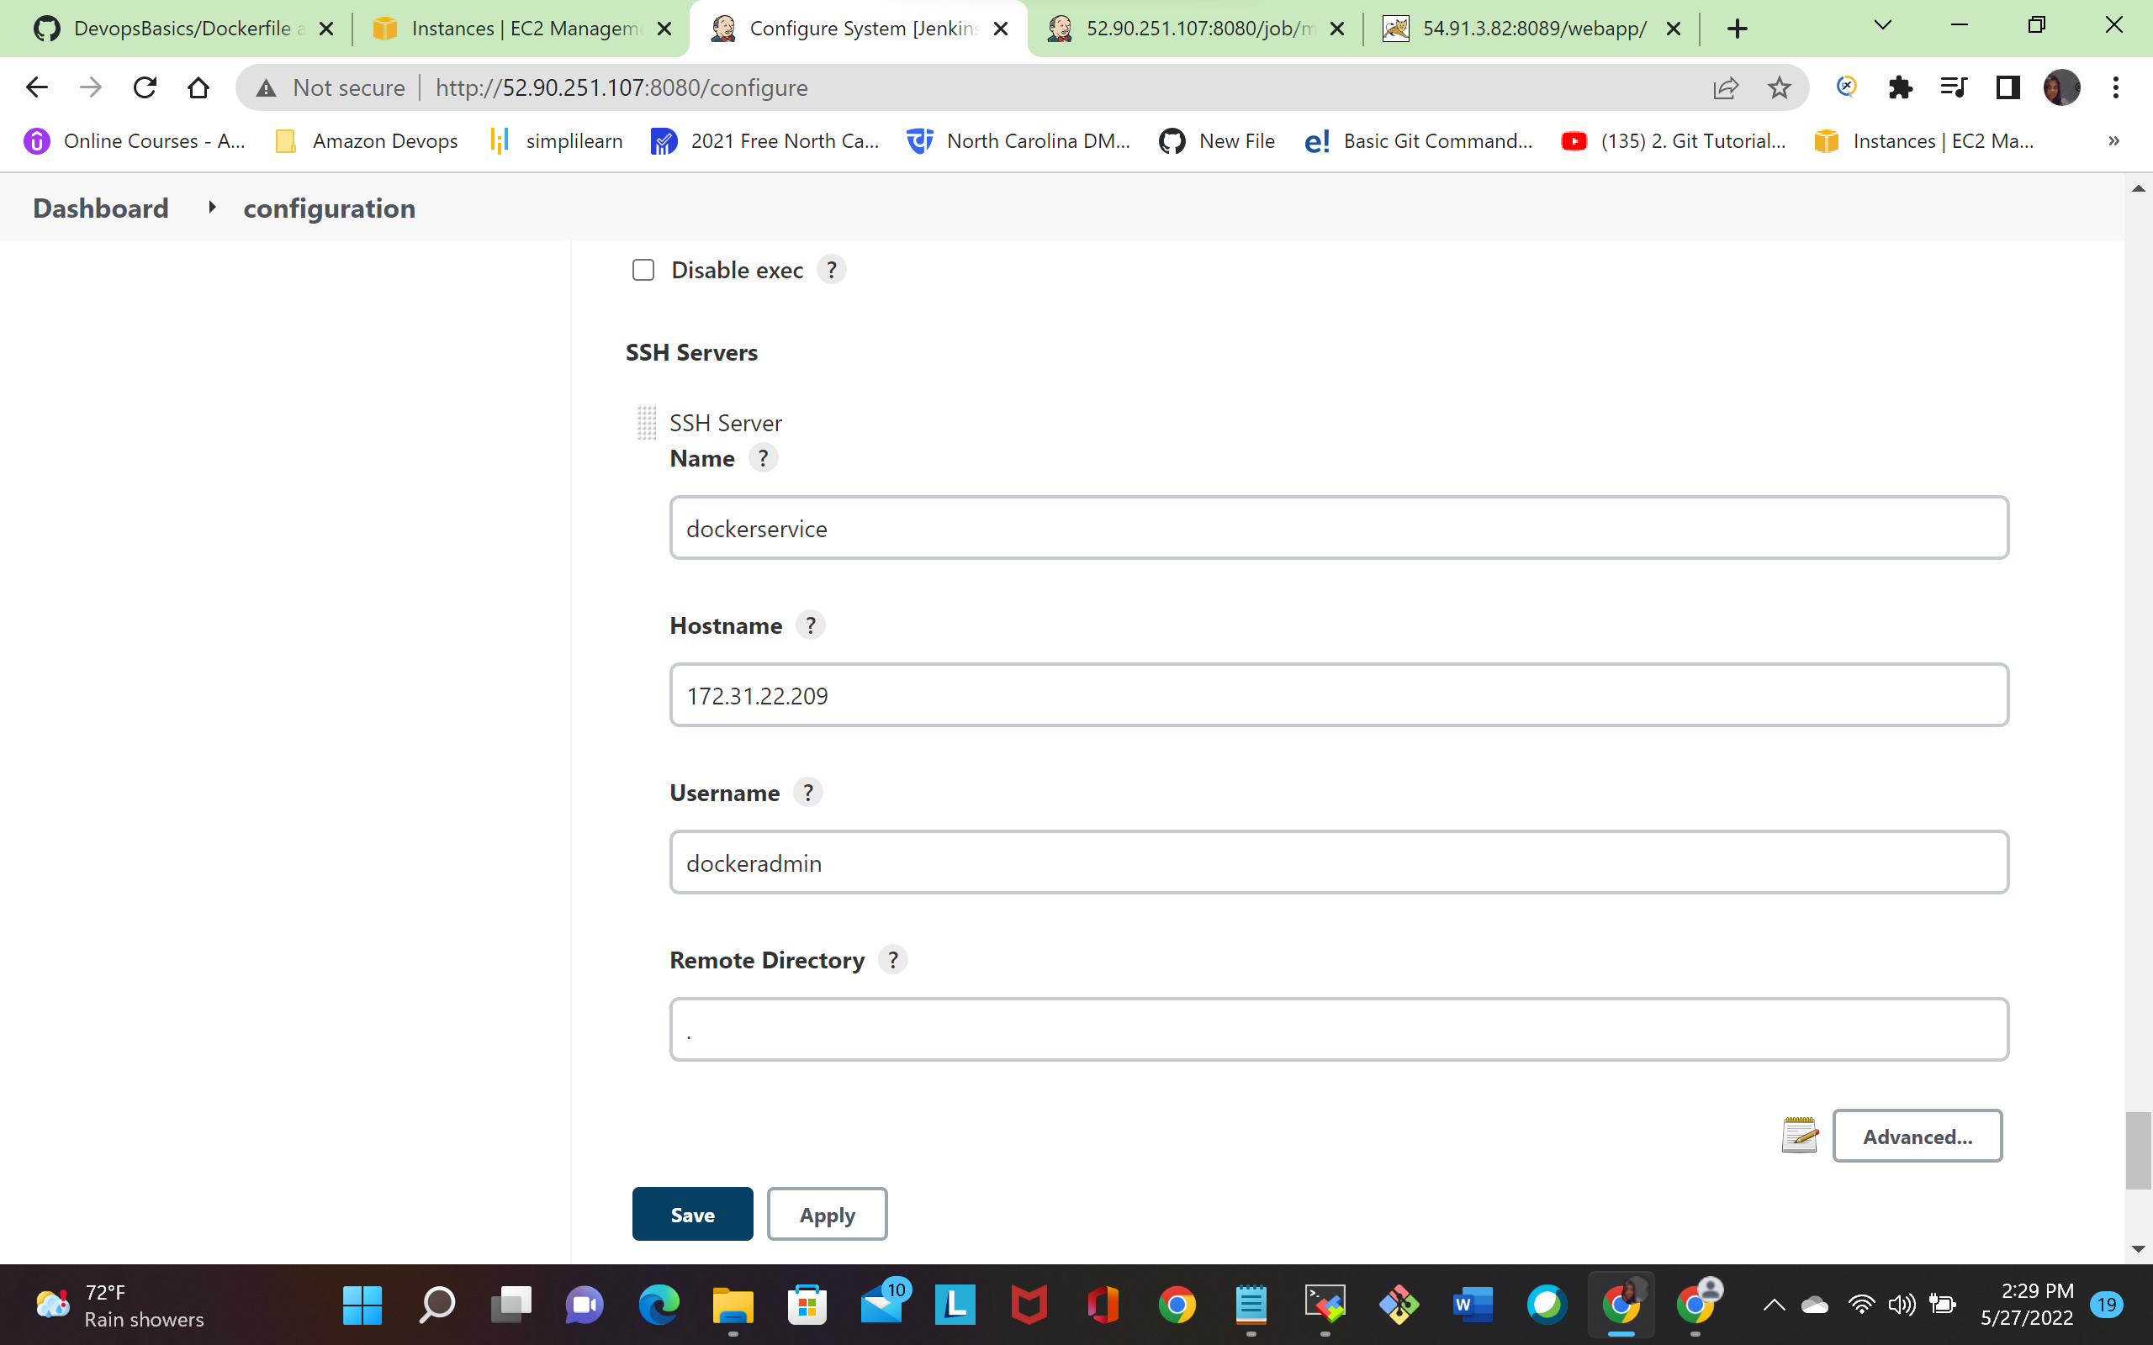

Once finishing all configuration. Next step is to create a new job for pushing docker image using dockerhub

Click on New Item. It will navigate you to the following screen:

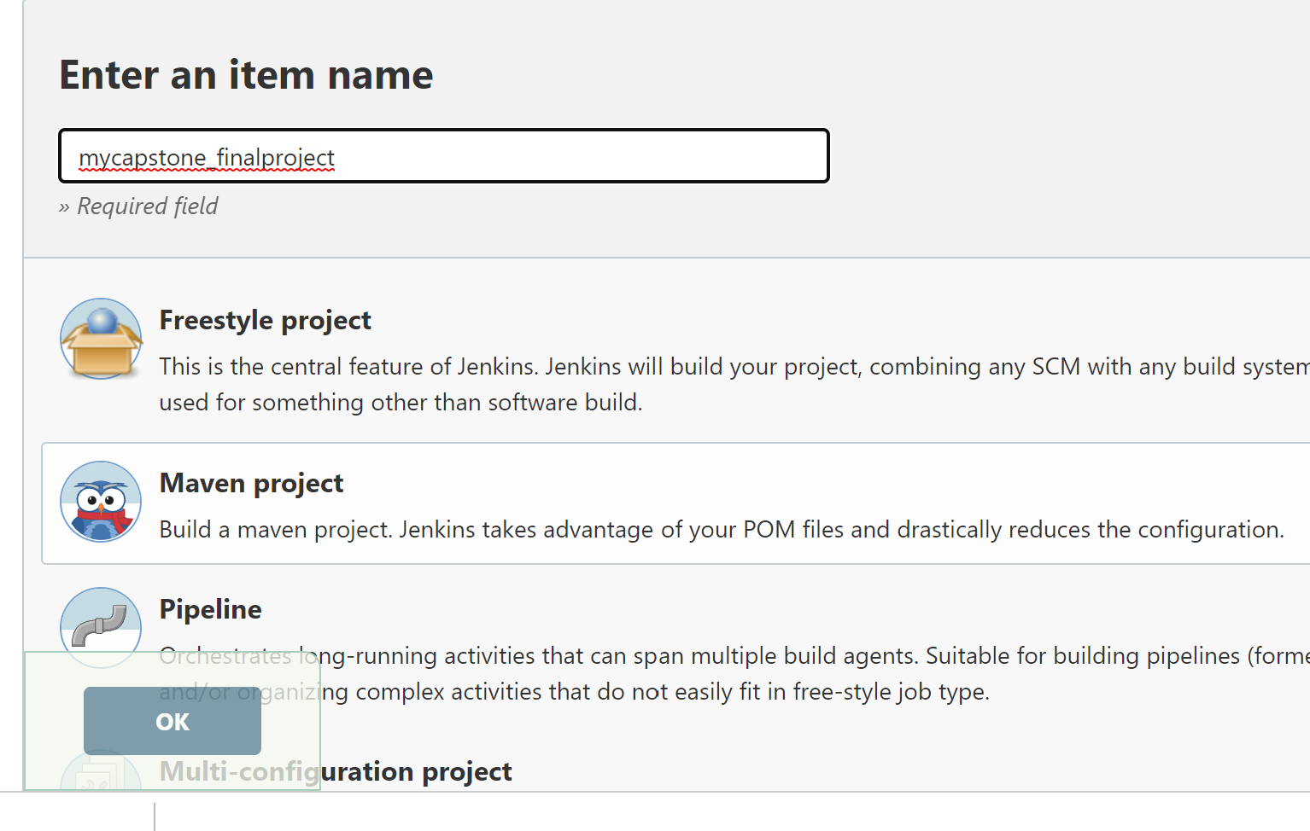  
Click on Maven Project and provide a name for project(mycapstone_finalproject).

Once done, click on Ok button.

Navigate down to general Section and give description about project,next navigate to source code management give git repo URL

(<https://github.com/vanishankar/myrepo.git>)

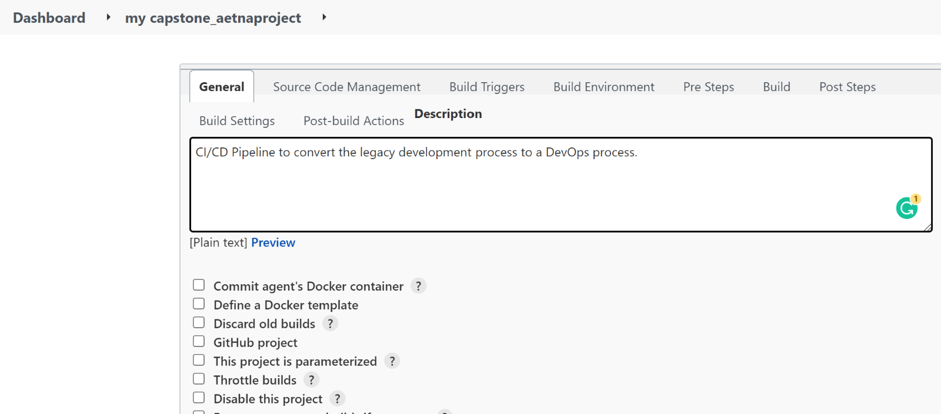

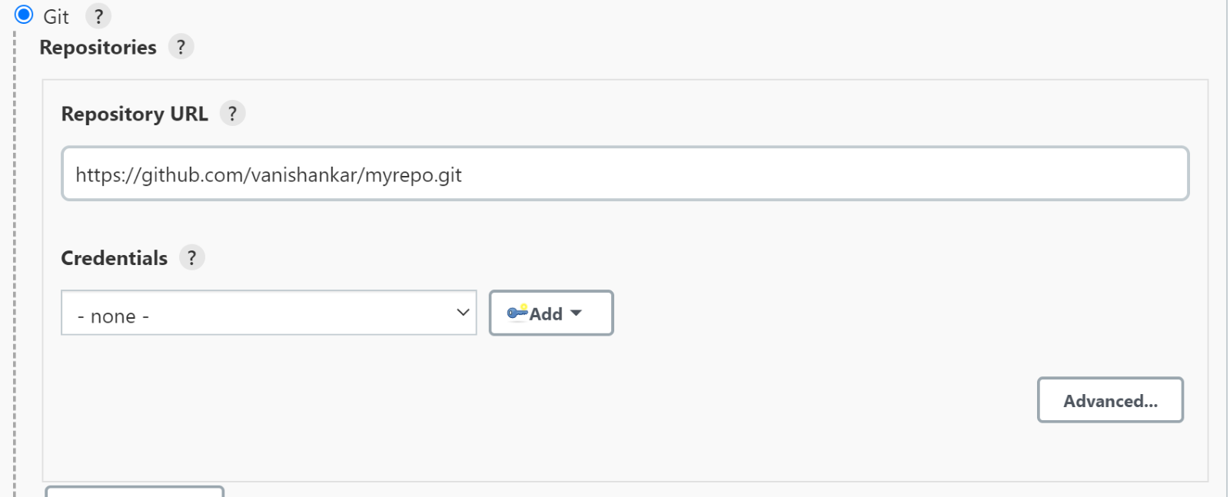

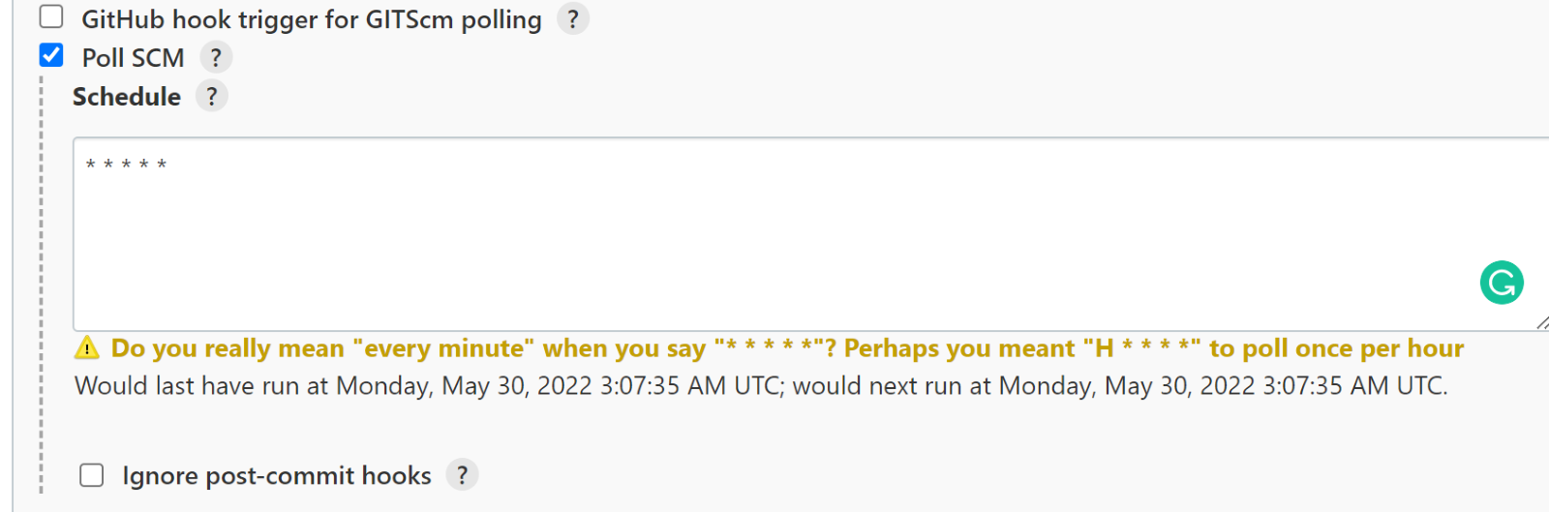

Next navigate to pre steps select top level maven goals shown in foll fig

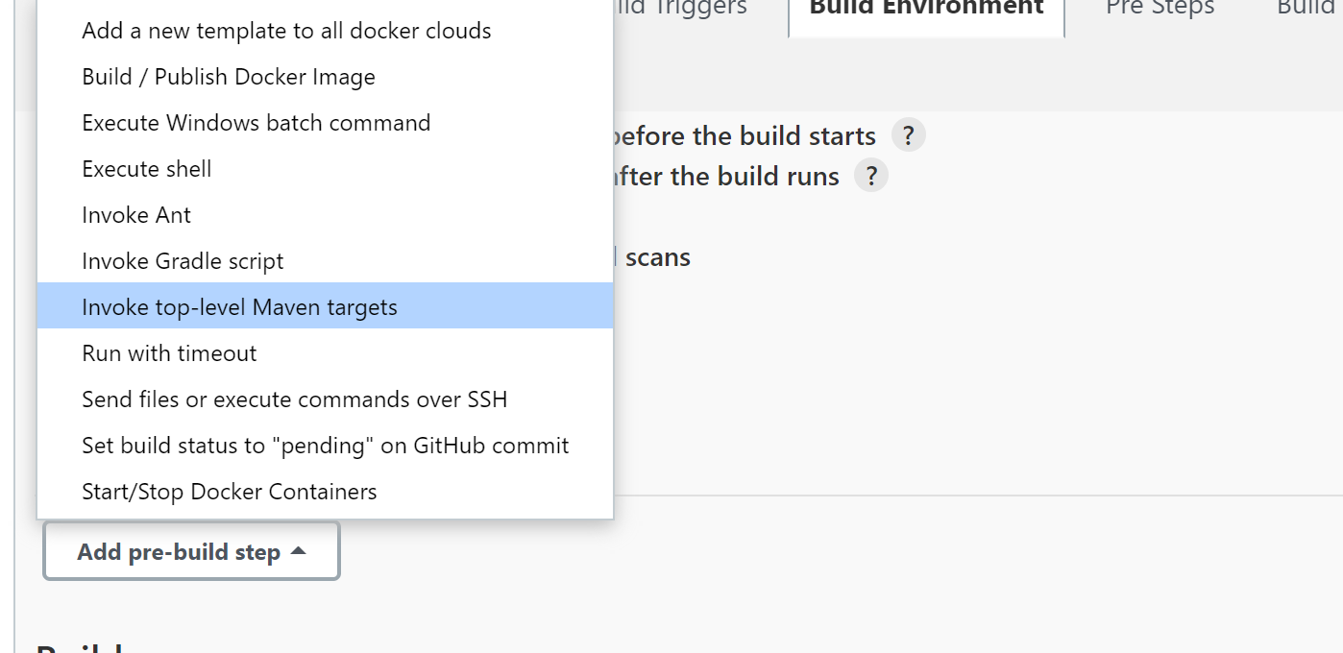  
and give maven goals clean, install,package

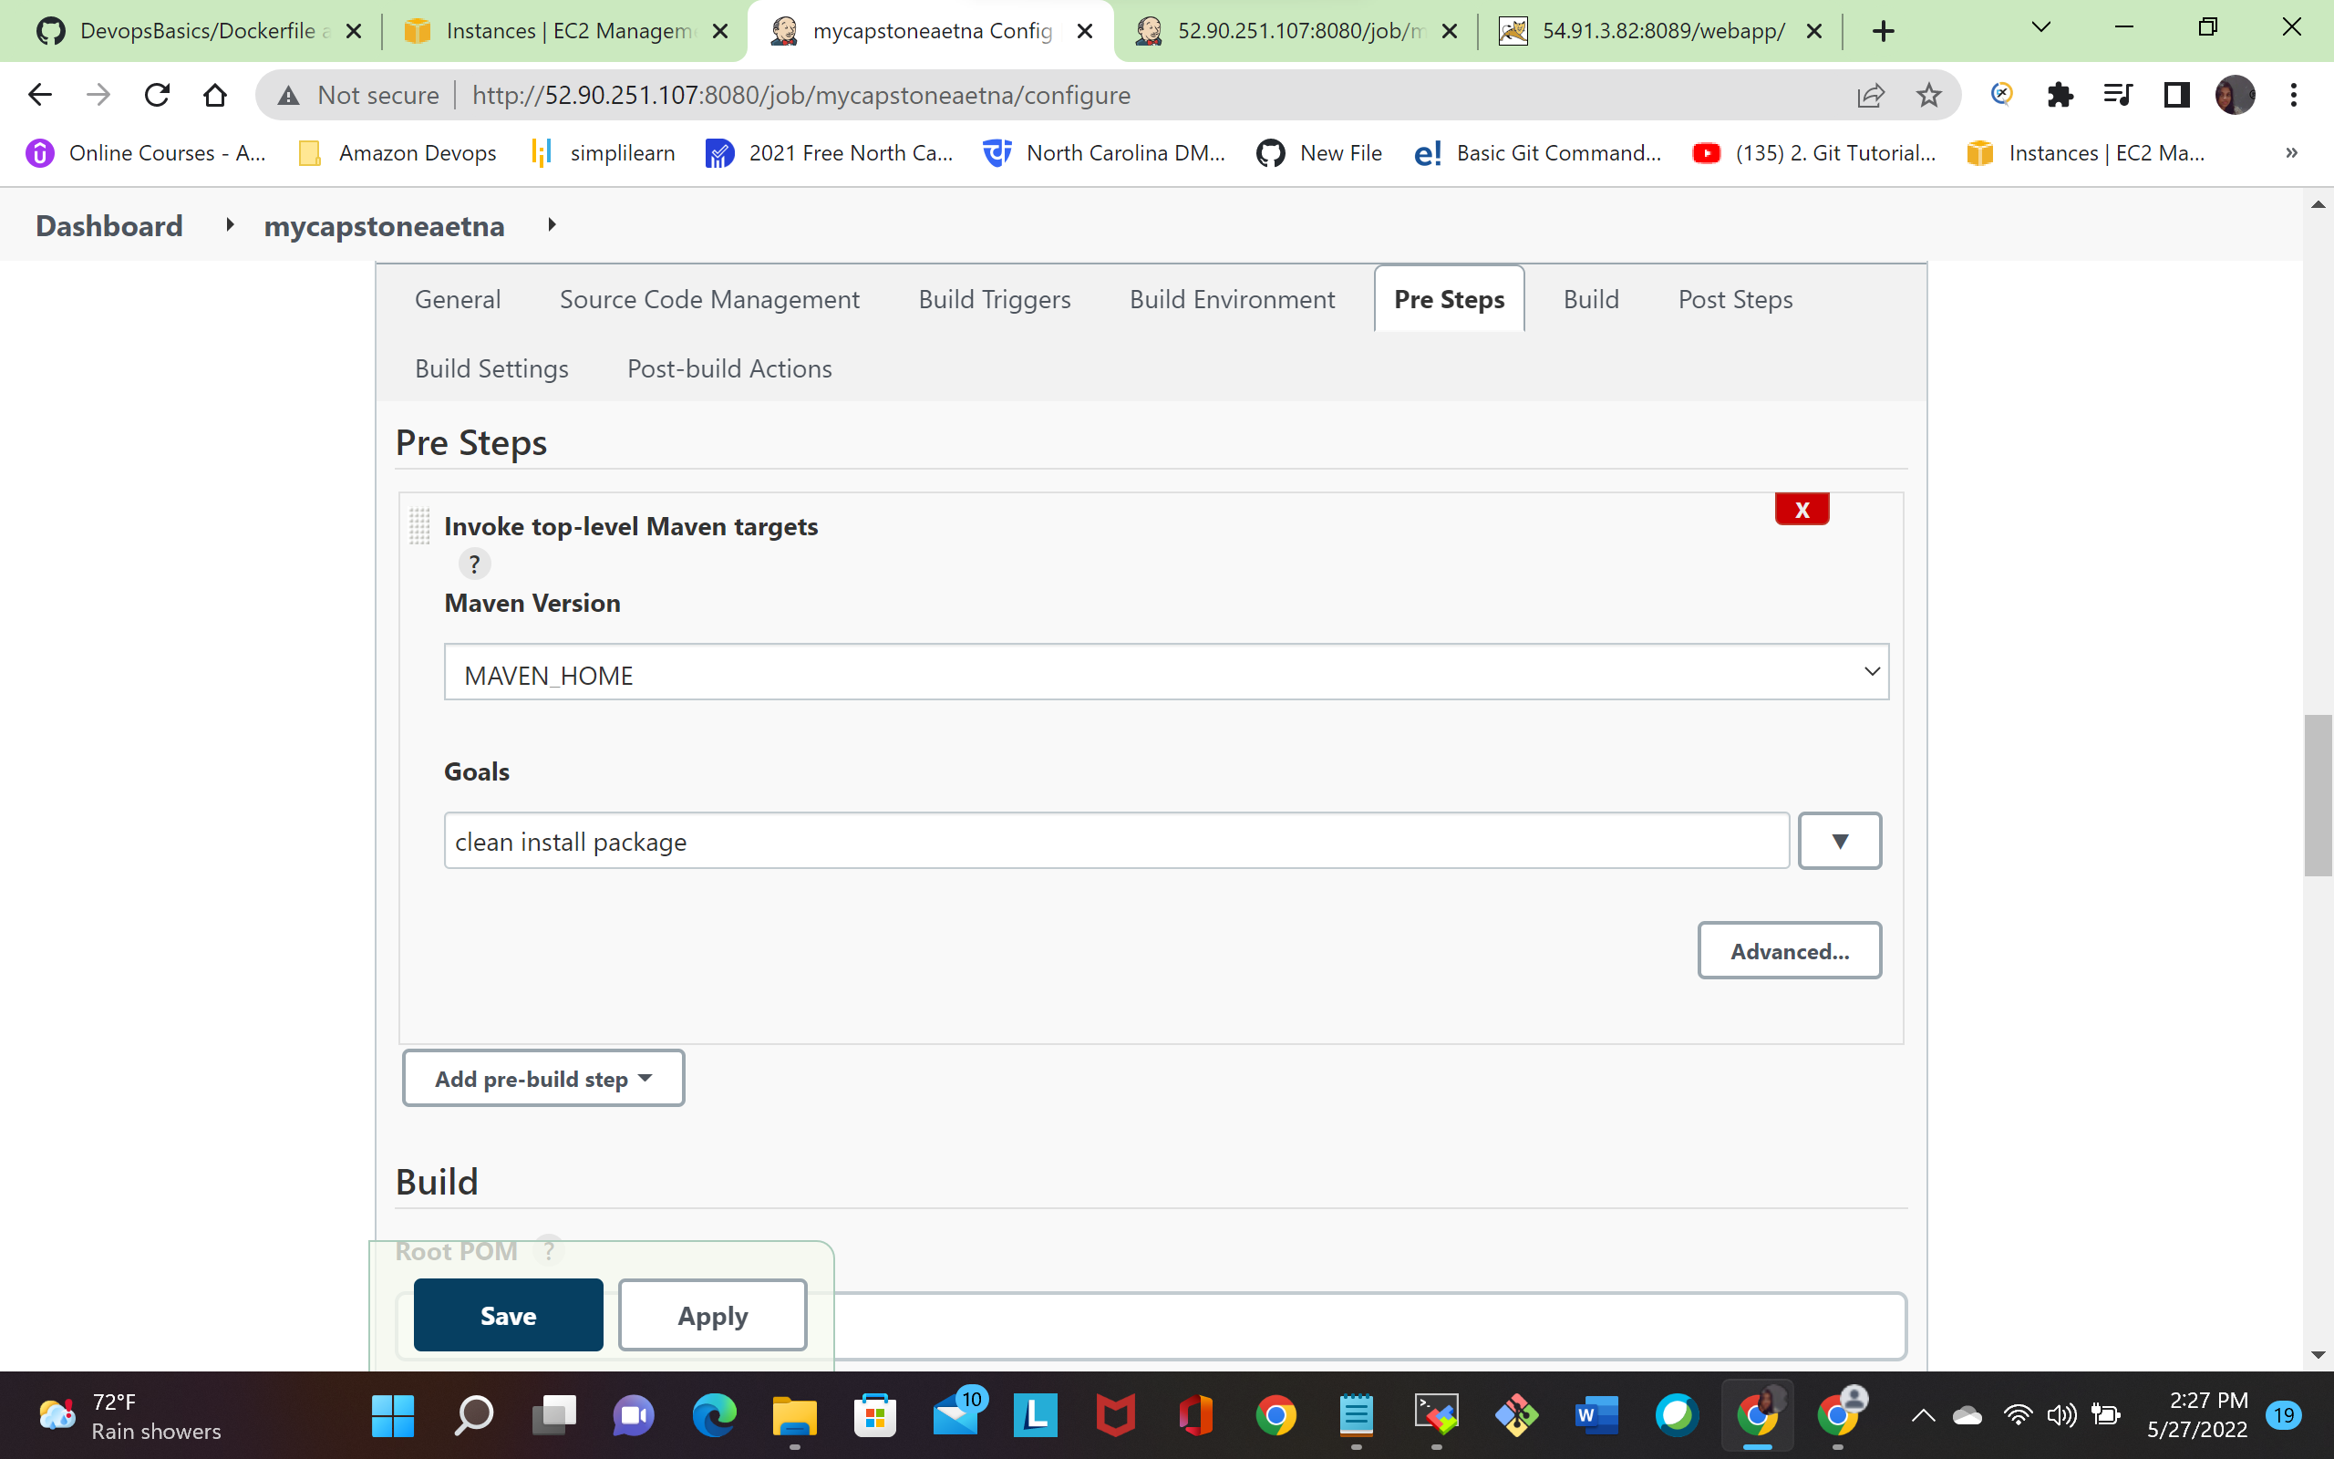

Next navigate to post steps click send build artifacts over ssh( to build artifacts to docker server)

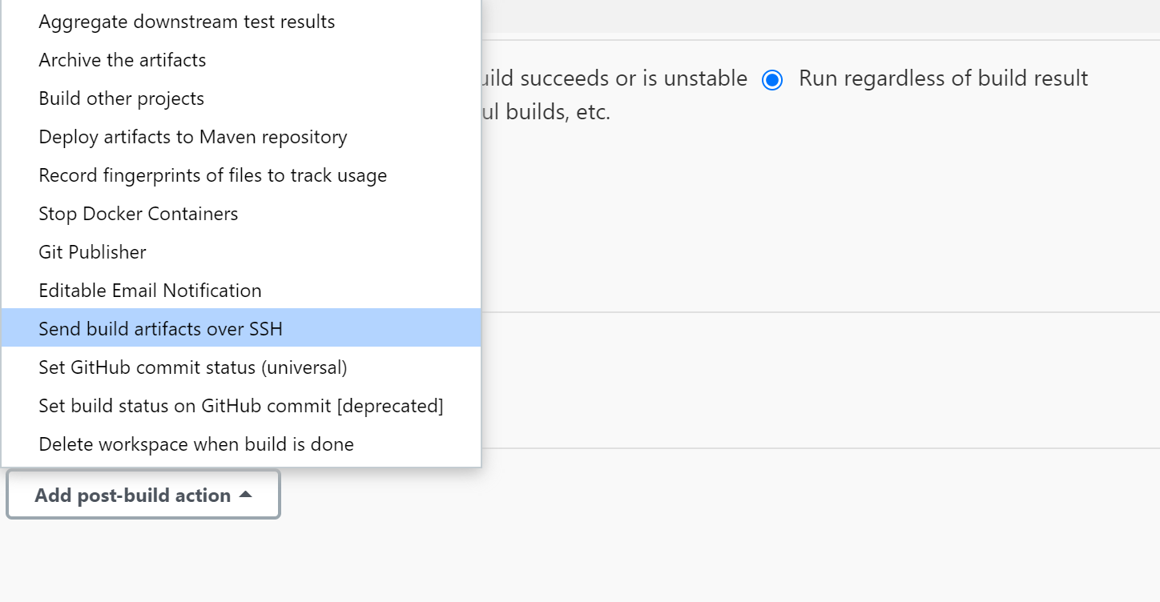

And give the source files path ,choose the remote directory to store the war file  
  
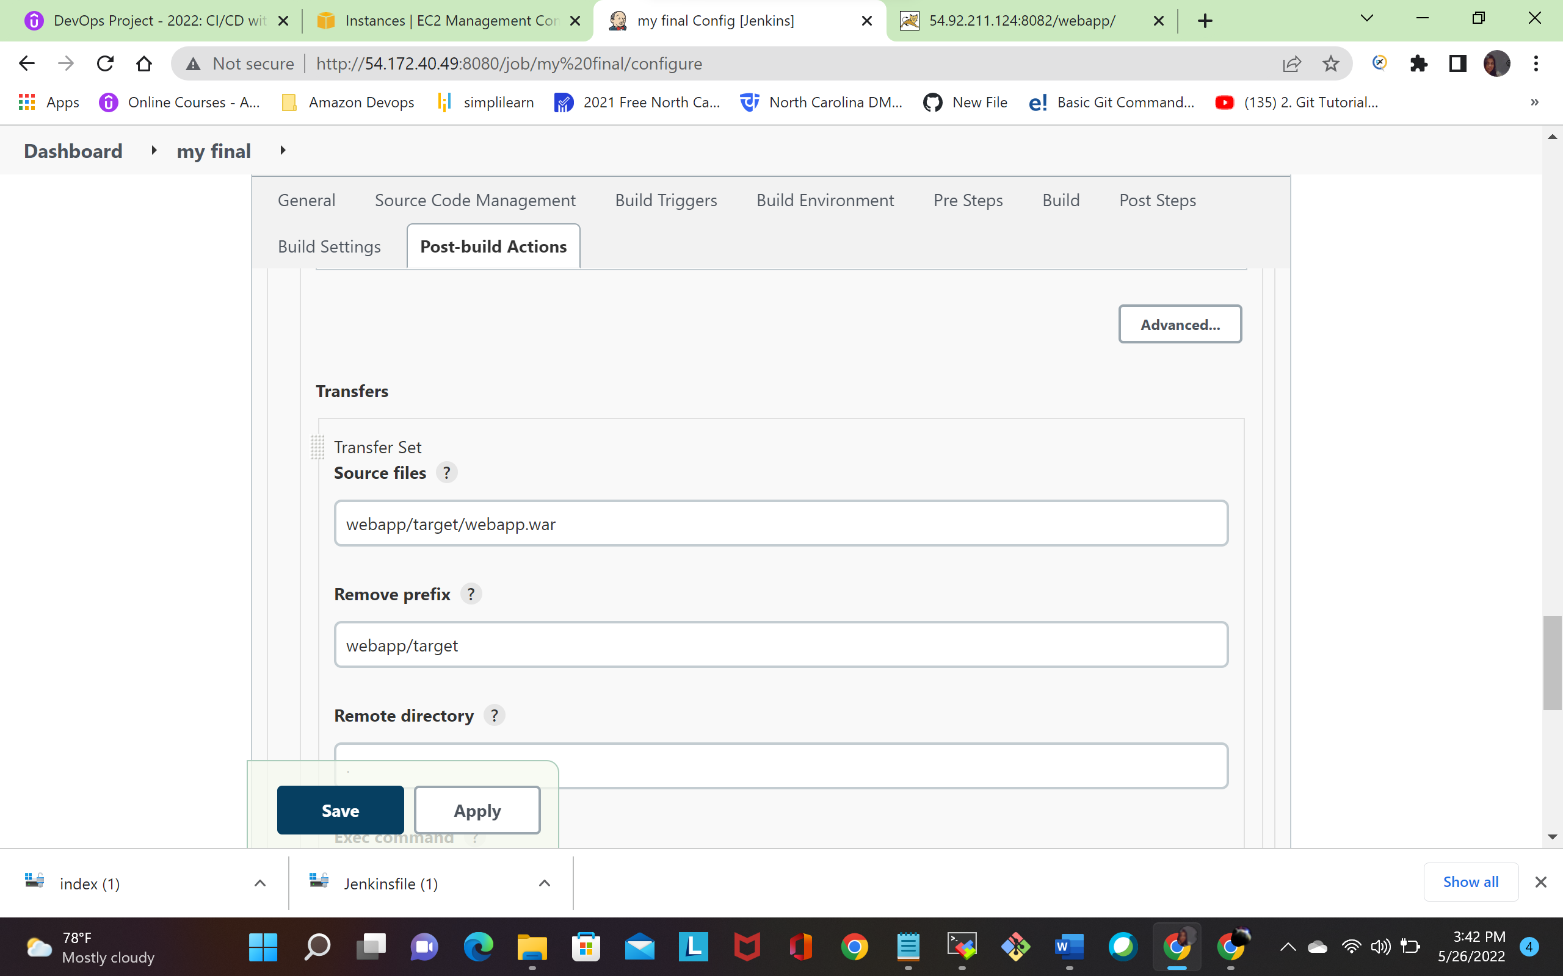  
and click exec command to automate docker file and give the following command

docker build –t aetnaprojects .

docker run –d –name company –p 8082:8080 aetnaprojects

docker login

docker tag aetnaprojects vanishankar/aetnaprojects

docker push vanishankar/aetnaprojects

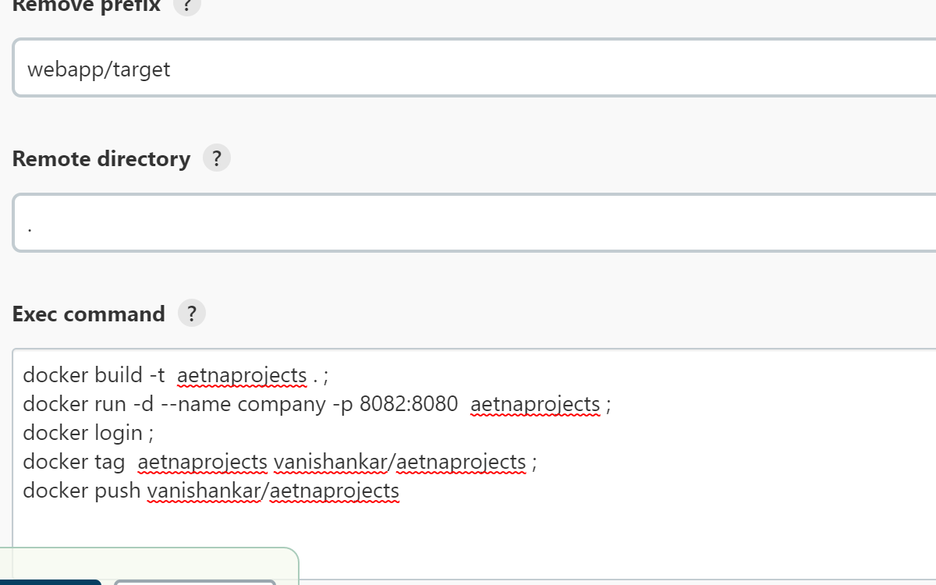  
click apply and save, go to dashboard click Build Now

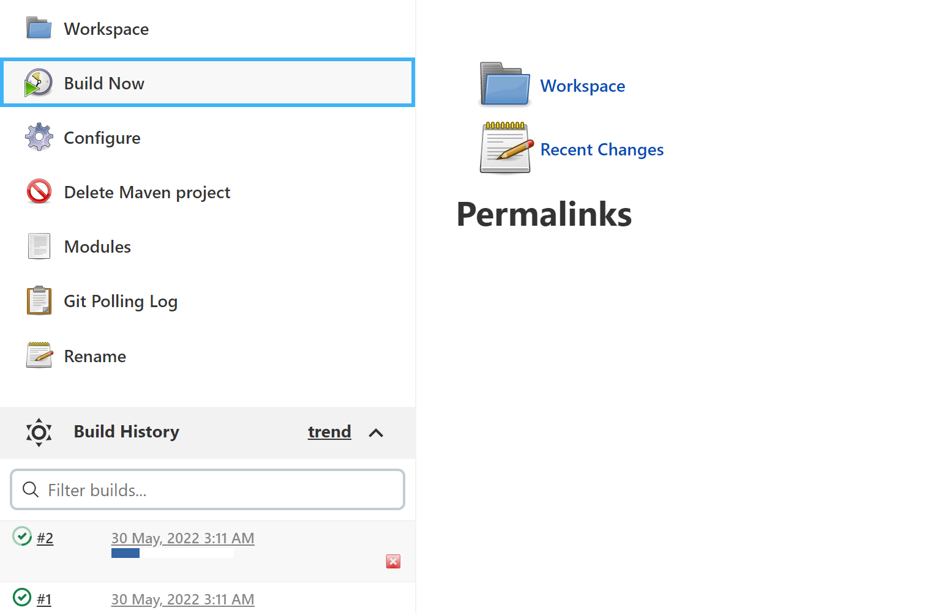

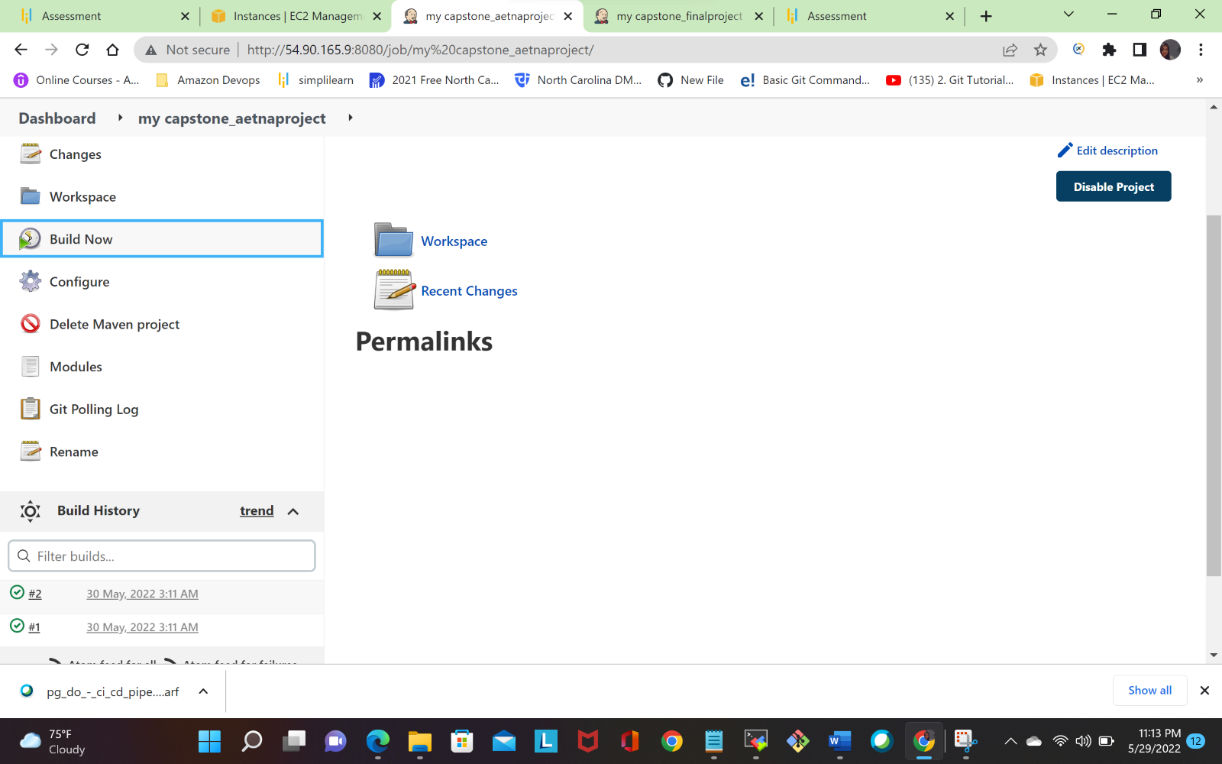

**Output: -**

The following fig shows output of our job

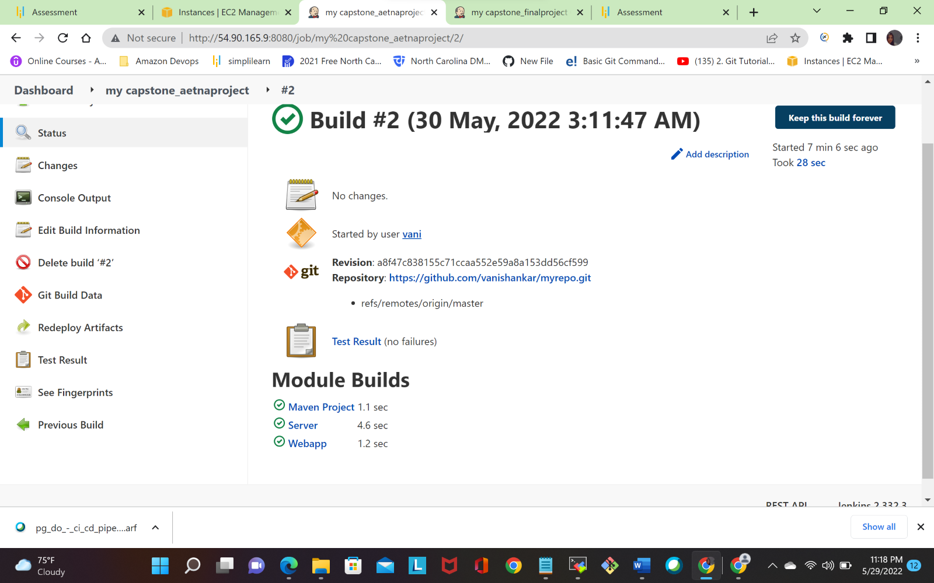

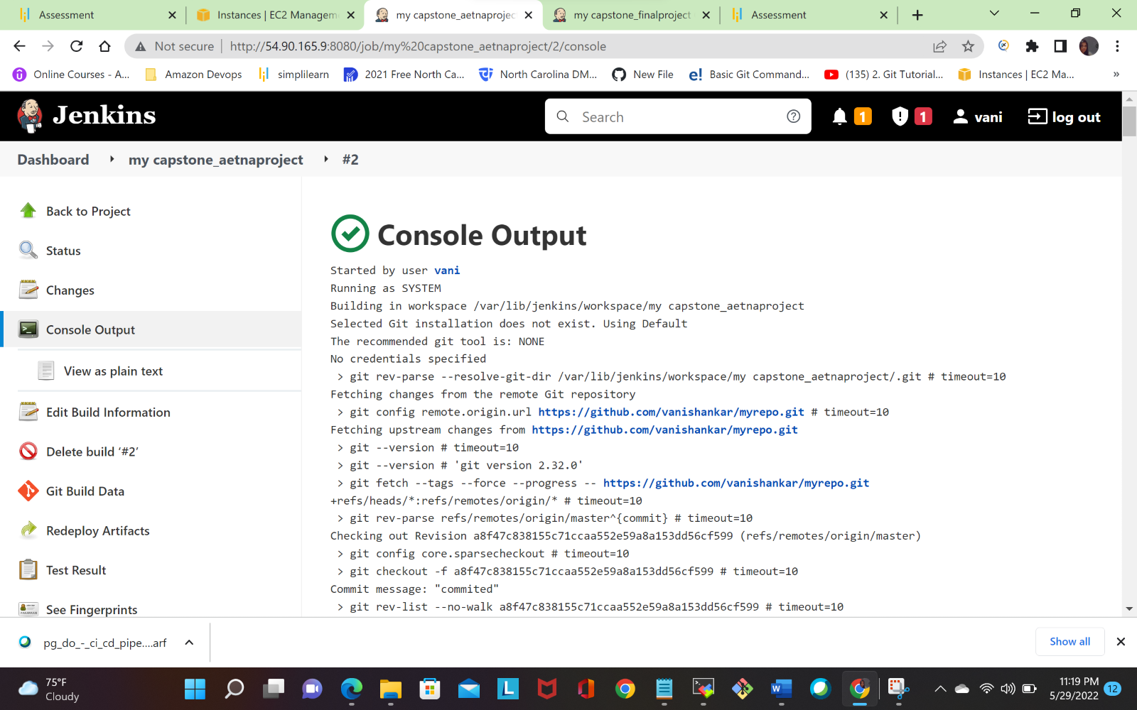

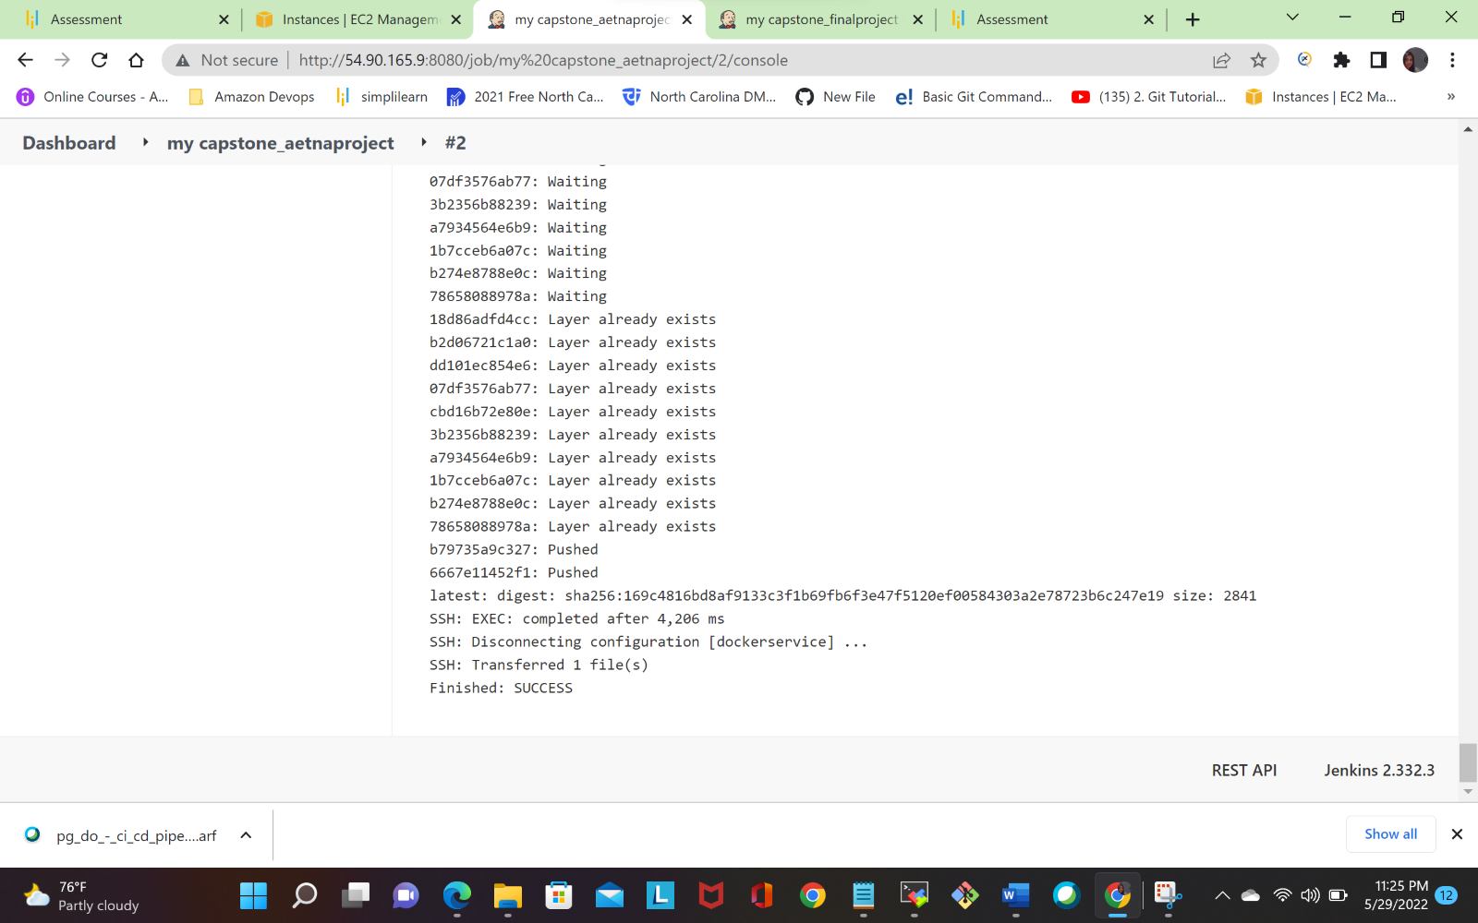

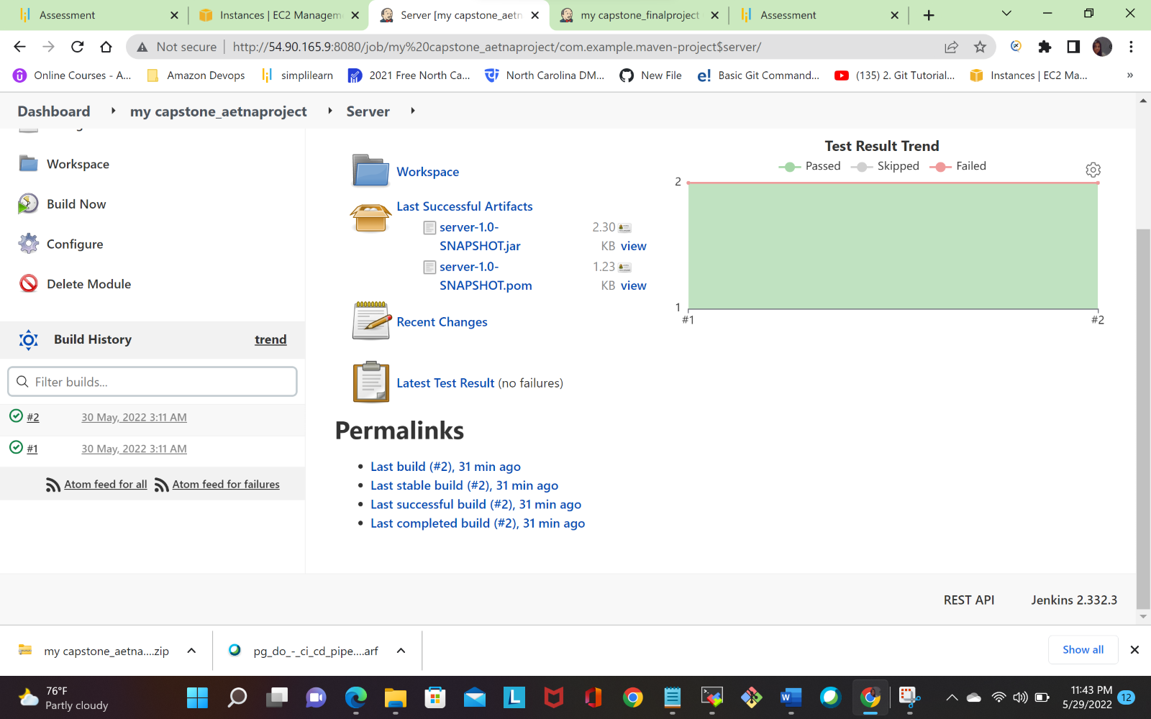

Test Result:-  
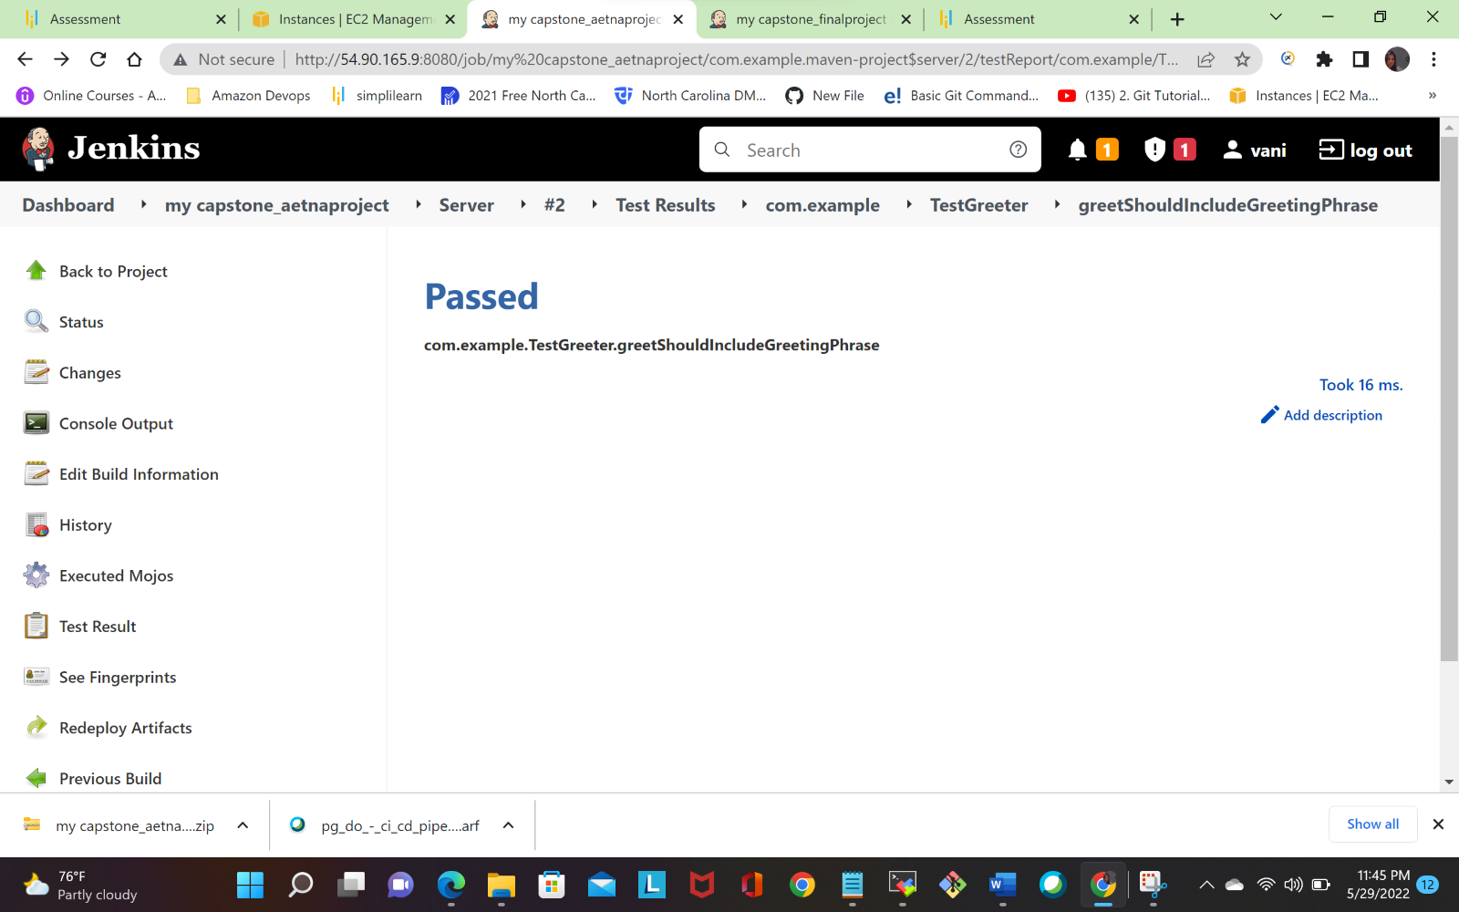

**Test Result: -**

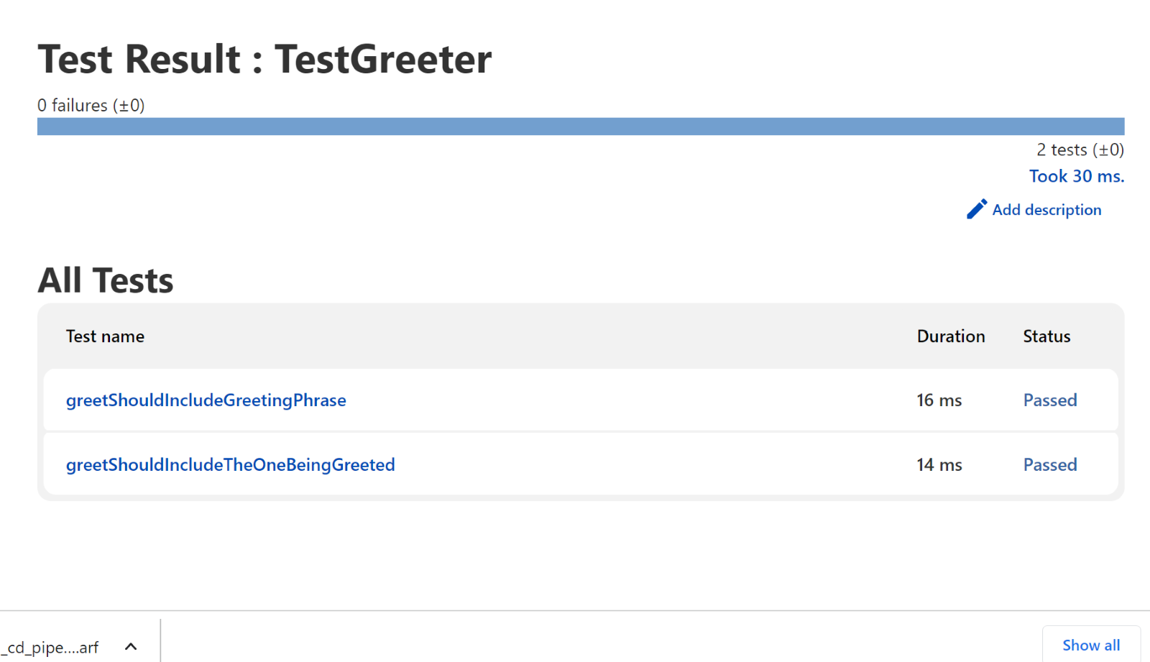

**Navigate to the browser access the webpage**

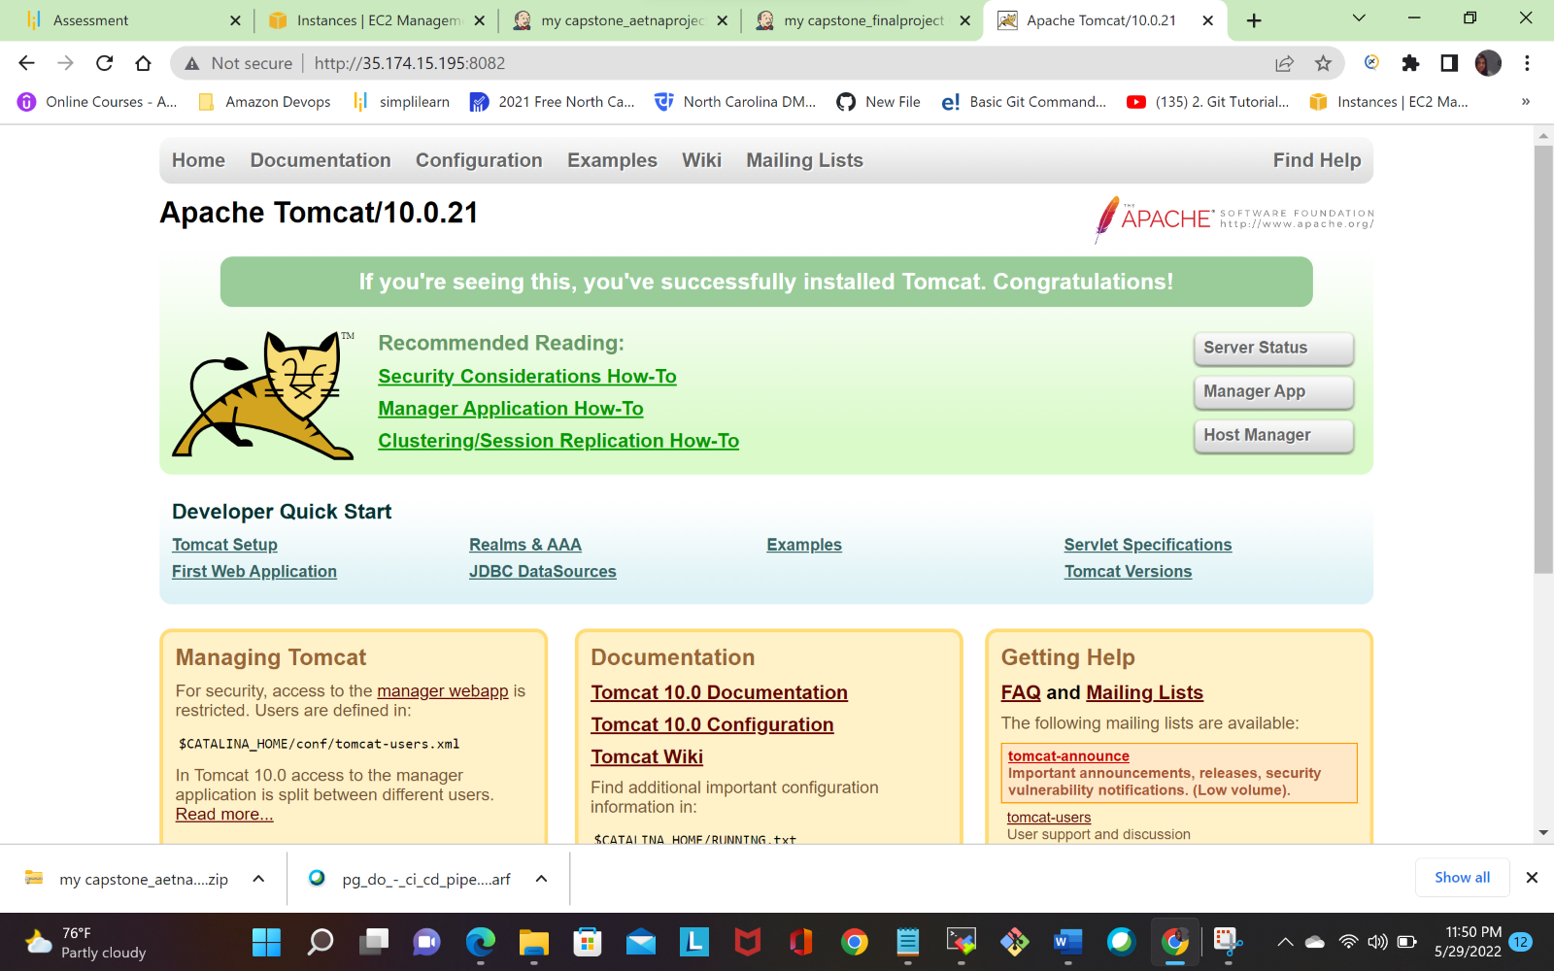

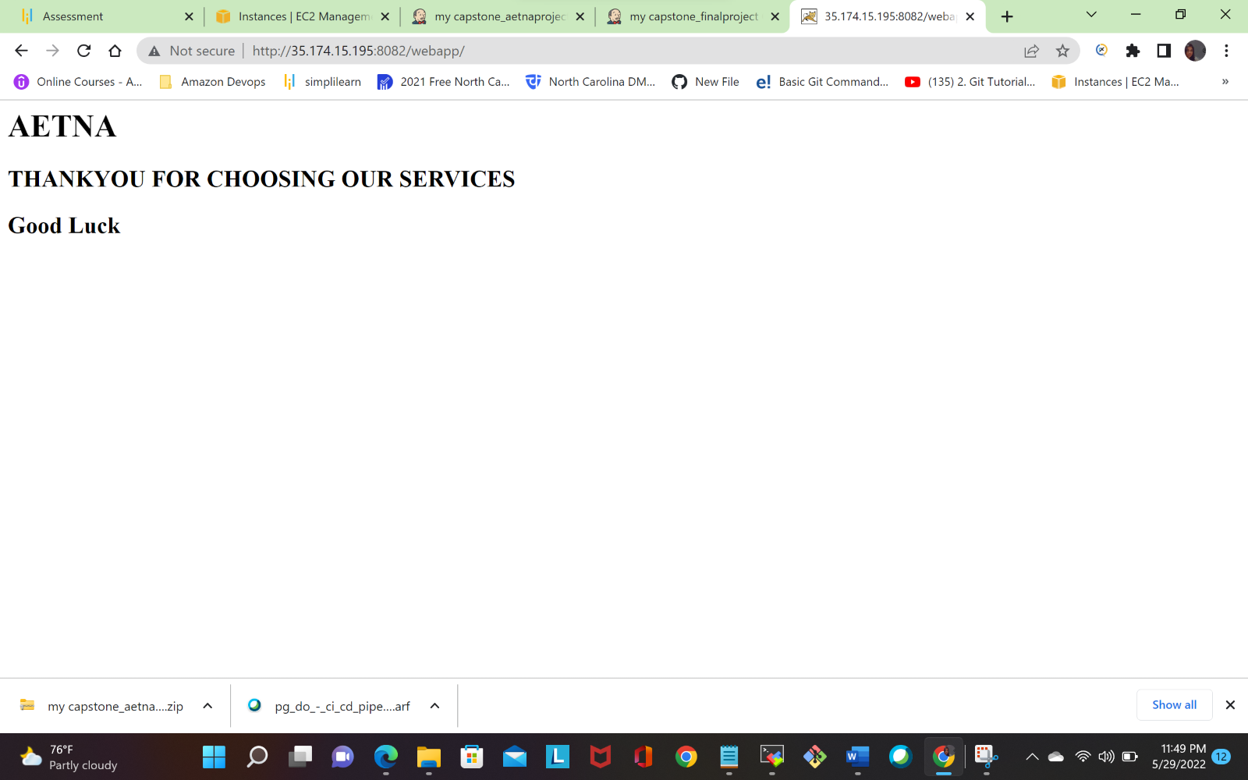

**Dockerhub:-**

Finally, our docker image is pushed in to dockerhub <https://hub.docker.com/repository/docker/vanishankar/aetnaprojects>

